Azure API Management

High Level Design

v0.1 (DRAFT)

Contents
1. Document Control 4
1.1. Document History 4
1.2. Document Authors 4
1.3. Document Assurance 4
1.4. TDA Approval 4
1.5. Document References 4
2. Executive Summary 5
2.1. Scope 5
2.2. Target Audience 5
2.3. Current State Summary 5
2.4. Existing API and Integration Landscape 5
2.5. Current API Consumption and Exposure Model 6
3. Architectural Position 7
3.1. Architectural Decisions 7
3.2. Requirements Traceability 8
3.3. Edge Gateway Selection Matrix 8
3.4. APIM Deployment Mode Decision 10
3.5. APIM SKU & Tier Decision 11
4. APIM Role and Positioning 13
4.1. Architecture Principles 13
5. APIM Architecture 14
5.1. High-Level Azure APIM Architecture 14
5.2. Logical Architecture Overview 14
5.3. Internal API Access Model 15
5.4. External API Access Model 15
5.5. Security Architecture 15
5.5.1 OAuth 2.0 Architecture 15
5.5.2 JWT Validation Architecture 15
5.5.3 APIM + Entra ID Integration 16
5.5.4 Secrets and Certificates Management 16
5.5.5 Zero Trust API Security 16
5.6. Deployment and Network Topology 16
5.7. End-to-End Request Flow 17
6. Network Topology and Connectivity Design 18
6.1. Ingress flow 18
6.2. Egress flow 19
6.3. Firewall integration 19
6.4. Traffic flows in detail 21
6.5. Configurations 23
‘6.6.1 Azure front door 23
6.6.2 APIM 23
6.6.3 Routing and subnet design 24
7. Traffic Management and Edge Security 27
7.1. Azure Front Door Vs Traffic Manager 27
8. Authentication and Security Design 28
9. API Product, Consumer and Developer Portal Model 37
9.1. Developer Portal 39
10. API Design, Policies and Governance 43
11. API Lifecycle and Versioning Strategy 44
12. Observability and Operations 45
13. Environment and Release Strategy 47
14. High Availability 50
14.1. Resilience Strategy 50
15. Capacity, Cost and Service Tiers 52
16. Operating Model 54
16.1. Operational ownership and support tiers 54
16.2. Incident management 55
16.3. Change and release management 55
16.4. Capacity, cost and service reporting 56
17. Service Handover 56
17.1. Handover readiness checklist 56
17.2. Early-life support (hypercare) 57
17.3. Documentation and knowledge transfer 57
17.4. Service acceptance sign-off 57
18. Risks, Assumptions and Decisions 58
18.1. High Level Impact Assessment 58
18.2. Assumptions 58
18.3. Risks 59
18.4. Issues 59
18.5. Dependencies 59
19. Appendices 60
19.1. Microsoft Reference Architectures 60
19.2. Alignment with the Azure Well-Architected Framework 60
19.3. Glossary and Definitions 61
19.4. Sample Policy Fragments, Naming and OpenAPI Skeleton 62
19.5. APIM End-to-end build and API onboarding flow 63

Document Control

Document History
Version | Date | Author | Change
0.1 | 21 September 2026 | Puneet Kumar | Initial draft restructured to the Organization’s HLD template

Document Authors
Role | Name / Team

Document Assurance
This document has been reviewed and approved by the following, the list has been grouped into different sections to aid readability as this document will be required at TDA.

Role | Description
Information | Shared for informational purposes including use as reference document for their domain’s documentation and processes
Reviewer | Actively reviews the content to ensure alignment to guidelines and policies and technical accuracy, will contribute as required
Approver | Provides assurance that their domain is correct in context of the HLSA

Date | Role | Name | Title
DD/MM/YY | Approver
DD/MM/YY | Approver

TDA Approval
The TDA approval date to be updated by the author once full TDA approval has been granted.
The document should then be updated to a major revision number and stored in the solution repository.

Date | Minutes (link) | TDA Chair Name | TDA Chair Title
DD/MM/YY

Document References
The following documents should be read in conjunction with this document:

Reference | Document | Version | Author | Source
1.

Executive Summary
Azure API Management provides a single, secure and governed platform for all organisational APIs internal, external, and partner. This document sets out the guidelines for standing up and operating the APIM platform and for onboarding APIs onto it, covering architecture, security, operational governance, and cost.

Scope

This High-Level Design (HLD) outlines the architecture, network design, security, governance, resilience, and cost model for adopting Azure API Management (APIM) as the central enterprise API gateway, along with the API onboarding pattern. It covers platform integration, security controls, APIOps automation, observability, high availability, and the operating model. Detailed configurations of backend systems and device-level firewall rules are out of scope and addressed in detailed design.

Target Audience
This document is intended for the Chaucer Technical Design Authority, enterprise and solution architects, and the platform, networking, security and integration teams who will build and operate the platform. It assumes familiarity with Azure and with enterprise integration concepts.

Business and architectural context
Chaucer currently relies on point-to-point integrations, file transfers, and direct system connections without a central API management platform. These individually managed interfaces offer limited standardization, visibility, and centralized governance across internal applications and external partner connections.
Introducing Azure API Management (APIM) establishes a central, enterprise-wide API layer. Rather than replacing the existing integration estate, APIM enhances it by providing a standardized framework for API publishing, security, access management, and lifecycle governance enabling scalable growth, security compliance, and asset reuse across the business.

Architectural Position

Architectural Decisions
This section records the design decision chosen for each key architectural area. Each row states the option selected not the full set of alternatives considered. Full comparison and why each choice was made, see the section where that decision is covered in detail. (sections 2.2 to 2.4) and the tier and cost options are compared in section 15 (Capacity, Cost and Service Tiers).
This table lists all the decisions in one place.
Area | Decision | Rationale
API Exposure | All managed APIs are published and exposed through Azure API Management. | Every API must be onboarded through a centralized gateway, direct backend exposure or informal bypasses are strictly prohibited.
External Access | Azure Front Door Premium with Web Application Firewall (WAF) is selected as the primary edge entry point over Application Gateway v2 (see the Edge Service Selection Decision section 2.2). | Similar baseline operational cost to Application Gateway WAF_v2, provides global edge routing, integrated CDN/caching, and future multi-region failover capabilities while reducing regional ingress and routing complexity.
APIM Tier | Azure API Management Premium v2. | Higher baseline cost than lower tiers, accepted for modernized architecture, enhanced scalability, complete networking flexibility, and alignment with Microsoft’s long-term APIM platform strategy.
Network Model | APIM deployed in Internal VNet integration mode with Private Endpoints / Private Link for backend services. | More network configuration up front, in exchange for no direct internet exposure anywhere
Resilience | Tiered Resilience Framework (Preferred: Silver)  • Bronze: Single-region, 1 unit.  • Silver (Default Production): Single-region, 2 units distributed across Availability Zones.  • Gold: Active-Active Multi-Region (Tier-1 mission-critical only). | Accepts an extended Recovery Time Objective (RTO) during a total regional outage while automated pipelines provision and configure the secondary region. In exchange, this eliminates 24/7 idle secondary region costs while maintaining a near-zero Recovery Point Objective (RPO) via Git-driven infrastructure configuration.
Identity | Entra ID and OAuth 2.0 as the default authentication mechanism. | Legacy non-OAuth partners require a formally documented and approved architectural exception rather than ad-hoc configurations
Delivery | All infrastructure, APIM policies, and route configurations are fully defined as code (IaC) and deployed via automated CI/CD pipelines | Slower initial setup and onboarding times compared to manual portal edits, in exchange for predictable, audited, and repeatable deployment workflows.

Requirements Traceability
High-Level Requirements Traceability Matrix
Chaucer's stated high-level requirements for the APIM platform, drawn from the Systems Integration Framework and the agreed scope, are traced below to the section of this HLD where each is designed and addressed.
Ref | Requirement (from the SIF and Chaucer’s stated scope) | Primarily addressed in
R1 | Enable API discovery and consumption by internal and external users | Section 9
R2 | Provide secure access to services exposed by the API | Section 8
R3 | Authentication approach (Azure Entra ID / OAuth 2.0) | Section 8
R4 | Allow controlled access to APIs from Chaucer private and public endpoints | Section 2.2, Section 2.3, Section 7
R5 | Provide access to backend APIs from Chaucer networks (Azure VNets, Azure PaaS, public SaaS) | Section 6
R6 | Protect API endpoints from common web and API hacking techniques, including but not limited to DDoS and OWASP Top 10 | Section 2.2, Section 7
R7 | Provide a robust service with High Availability | Section 14
R8 | Provide backup and disaster recovery | Section 14
R9 | Detail HLD-relevant versioning and lifecycle | Section 11
R10 | Detail HLD-relevant observability and policies | Section 10, Section 12
R11 | Traffic Manager concepts and supporting components | Section 2.2, Section 14.2
R12 | Cost-effective but segregated environments to support release management (Prod/UAT/Dev) | Section 13, Section 15

Edge Gateway Selection Matrix
The table below shows how each edge gateway option aligns with the defined requirements, providing the basis for selecting the preferred edge gateway service.
Criteria  (Aligned to requirement) | Front Door Premium + WAF | App Gateway v2 + WAF | Front Door Premium + App Gateway  (Both Combined)
Global routing (R1, R11) | Yes | No | Yes
Multi-region support (R7, R8) | Yes | Limited | Yes
WAF protection (R6) | Yes | Yes | Yes
Private Link to APIM (R4, R5) | Yes | Limited | Yes
Performance (R7) | High | Regional | Highest
Operational complexity (R12) | Low | Medium | High
Cost (R12) | Medium | Medium | High
Recommended | Yes | No | No

Selection rationale, when to choose which edge gateway:
Option | Primary Architectural Intent | Reasoning
Front Door Premium + WAF (chosen) | Global Edge, Multi-Region & Unified Ingress | Front Door Premium + WAF is the requirements-aligned, cost-effective choice: it meets every requirement in this matrix. It combines global routing, managed WAF/DDoS, and native Private Link into APIM within a single, low-maintenance service, satisfying R1 (discovery and consumption by internal and external users), R4 (controlled private and public endpoint access), R6 (DDoS and OWASP Top 10 protection), R7 (high availability), R11 (Traffic Manager-equivalent global routing) and R12 (low operational complexity for cost-effective, segregated environments).
Application Gateway v2 + WAF | Regional-Only Ingress & Strict Data Residency | Application Gateway v2 + WAF was not selected because it only partially meets the defined requirements. Although it satisfies R5 (backend network access) and R6 (WAF protection), it lacks native global routing (R11), does not fully support the target consumption model (R1), and requires additional components to achieve multi-region resilience (R7/R8). Consequently, it offers lower overall requirement alignment than Azure Front Door Premium + WAF.
Front Door Premium + Application Gateway | N-Tier Ingress & Deep Defence-in-Depth | Front Door Premium + Application Gateway v2 + WAF was not selected because the additional inspection and routing capabilities do not address any unmet requirements. Although it provides the strongest alignment to R2 and R6, it introduces extra cost and operational complexity, reducing alignment with R12. Front Door Premium + WAF delivers the required functionality more simply and cost-effectively.
Direct APIM ingress  (No edge service) | Private / Internal-Only Services | Direct APIM ingress was not selected because it only aligns with internal-only API consumption scenarios. It does not meet the requirements for external access (R1), edge security protection (R6), or global routing and availability (R11). Consequently, it provides insufficient requirement coverage for the target API platform.
Microsoft Source: learn.microsoft.com/azure/architecture/web-apps/api-management/architectures/protect-apis

APIM Deployment Mode Decision
To ensure a strict security boundary, Azure API Management must be isolated from direct internet exposure. Selecting the deployment mode dictates how the gateway integrates with our virtual network (VNet) and forces all external consumer traffic through Azure Front Door Premium WAF via Private Link.
The table below details the evaluation between Internal VNet, External VNet modes and VNet Integration.
Option | Description | Status | Architectural Rationale
VNET Injection Internal mode | APIM is deployed fully inside a dedicated VNet subnet with no public IP address. Ingress from Front Door Premium is routed privately via Private Link / Private Endpoints, and backend access uses private VNet routing. | Chosen | Zero Internet Exposure: Completely isolates the API gateway from the public internet. Guarantees that all external traffic is inspected and forced through Azure Front Door Premium WAF before reaching APIM.
VNET Injection External mode | APIM sits inside a VNet but maintains a direct, publicly accessible IP address on the internet, allowing clients to bypass or hit the gateway alongside an optional edge service. | Not Chosen | Security & Compliance Risk: Exposes a public surface area directly to the internet, creating potential governance bypasses where consumers can hit APIM endpoints without traversing the centralized Front Door WAF edge.
VNET Integration | APIM connects to backend services through a dedicated integration subnet, allowing private access to internal networks, Azure services, and external SaaS platforms without exposing a public IP for outbound traffic. | Not Chosen | Backend Reachability: This option still exposes a public surface area to the internet while the backend access can be achieved without introducing a dedicated integration subnet and associated networking complexity. While it supports private access to Azure and external services, the selected approach provides sufficient connectivity while maintaining a simpler operational model and lower cost.

APIM SKU & Tier Decision
This section evaluates APIM Premium v2 against the available APIM tiers and identifies Premium v2 as the preferred platform standard. Premium v2 best aligns with the target architecture requirements for security, scalability, networking, and resilience, while the Developer and Standard v2 tiers provide insufficient secure capability needed for Production and UAT environments.

Capability | Premium v2 | Classic Premium | Decision & Rationale
Simplified Networking Model | Yes | No | Premium v2 significantly reduces virtual network governance overhead by eliminating dedicated control-plane routing dependencies.
Private Networking / Isolation | Yes | Yes | Both tiers fulfil strict security policies by providing private endpoint connectivity and network isolation
Workspaces | Yes | Yes | Both tiers support workspaces for decentralized API publishing and domain isolation across business units.
Futureproofing | Yes | No | Premium v2 positions the platform on Microsoft's newest architecture, avoiding future migration rework from Classic Premium.
Multi-Region Topology Strategy | Regional Deployment | Native multi-Region | Premium v2 supports single-region zone redundancy per instance, aligning perfectly with our Silver Resilience Tier

Premium v2 GA backed by Microsoft: Premium v2 general availability announcement, techcommunity.microsoft.com/.../premium-v2-tier-ga; multi-region tier support confirmed in Microsoft’s reliability guidance for API Management.

Principles
This section sets out the architectural standards and guardrails that every API on the platform must follow. They operationalize the single-ingress decision recorded in Section 2.1 and are stated here as concrete, enforceable rules rather than general narrative.
What this means in practice
- All Ingres traffic follows the mandatory path: Consumer → Azure Front Door + WAF → APIM → Backend Services.
- APIs are published through APIM and discovered through a central catalogue.
- Authentication is managed through Microsoft Entra ID.
- Secrets and certificates are managed through Azure Key Vault.
- API access is governed through products, subscriptions, and policies.
- All platform and API changes are deployed through APIOps pipelines.
- Usage, performance, and security events are centrally monitored and audited.
- Point-to-point integrations are minimised in favour of reusable, managed APIs.

APIM Architecture

High-Level Azure APIM Architecture

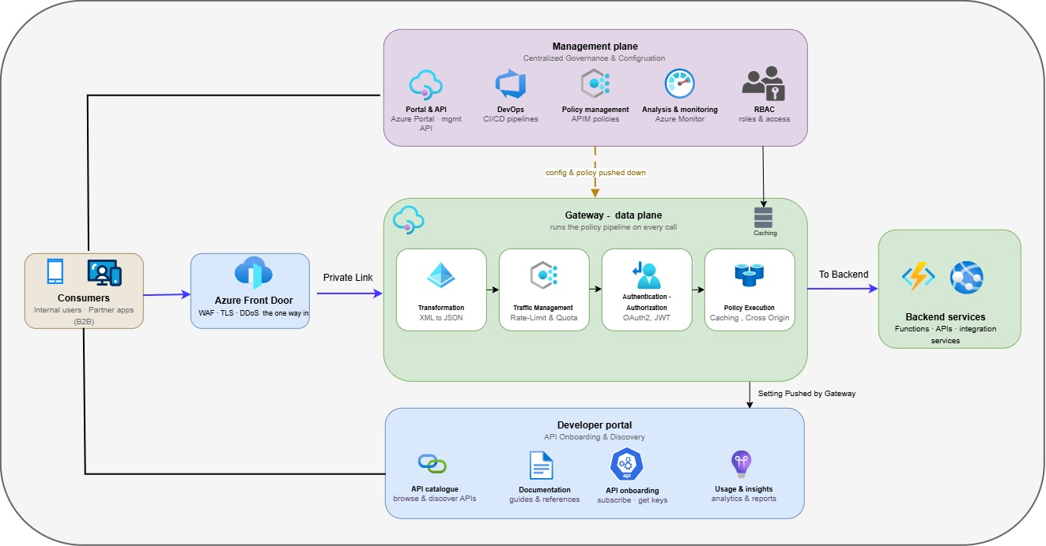
The Architecture has these parts:
- Gateway (data plane). The engine that handles live traffic. Every call pass through it and it applies the same set of rules, authentication, rate limits, validation, routing and logging, to each one. This is where the platform actually does its work.
- Management plane. Where the platform is configured. Teams define their APIs, products and policies here, and those definitions are pushed down to the gateway. It is used to set the platform up and change it, not to serve live traffic.
- Developer portal. The self-service website where consumers find the APIs they are allowed to use, read the documentation, and request a subscription. It is covered in full in section 9.
- Policies. The reusable rules the gateway runs on each call. They are written once and applied consistently, so security and behaviour do not have to be rebuilt for every API. Policy detail is in section 10.

Logical Architecture Overview
The APIM platform is made up of a few distinct parts, each with a clear job. The diagram below shows how they fit together and how a request moves through them; the parts themselves are described underneath.

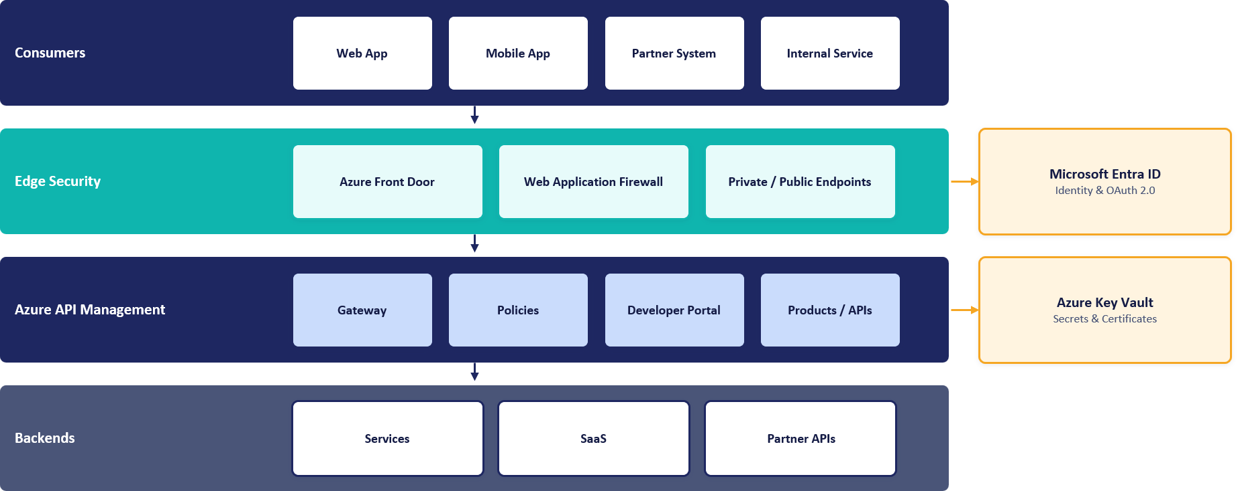
APIM service reference architecture, the logical components and how a request flows between them
Two shared Azure services sit alongside the gateway and are called on every request: Microsoft Entra ID validates the caller's token, and Azure Key Vault holds the secrets and certificates the gateway needs.

API Access Model and Security Boundary
All requests are processed by the same Azure API Management instance, but the path differs depending on where the consumer is located. External consumers enter through Azure Front Door and cross the internet boundary once, while internal consumers access APIM directly from within the corporate network and remain on private connectivity throughout.
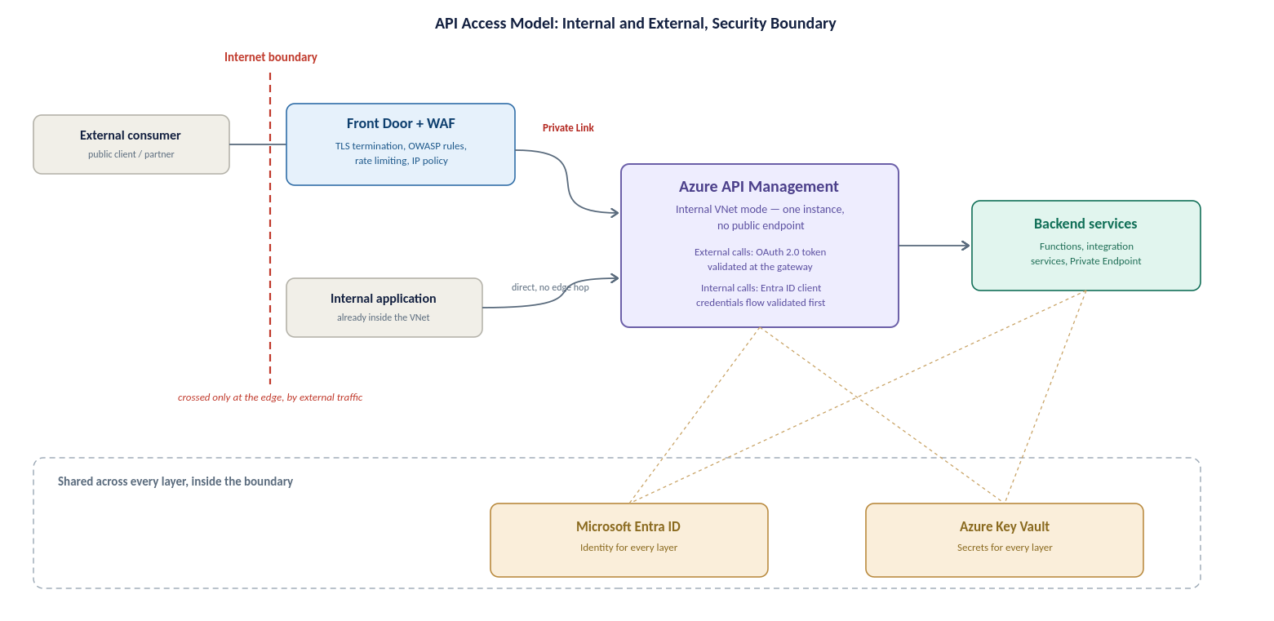
API access model and security boundary, internal and external paths converging on the same internal-mode gateway
External path: a public client or partner reaches Azure Front Door with WAF, which terminates TLS and applies OWASP protection at the edge before anything reaches APIM. The call then travels over Private Link to APIM, which validates the OAuth 2.0 token before forwarding it to the backend.
Internal path: an internal application calls APIM directly over the private VNet, with no edge service in the path because there is no public exposure to guard against. APIM authenticates the caller against Microsoft Entra ID, then routes the request to the target backend.
Both paths terminate at the same internal-mode gateway and the same backend estate; only the entry point and the authentication mechanism differ.

Traffic Management and Edge Security

Azure Front Door Vs Traffic Manager
Although Azure Front Door and Azure Traffic Manager share the primary goal of routing traffic to healthy regional origins, their underlying mechanics differ significantly:
- Azure Traffic Manager (DNS-Based Routing): Operates strictly at the DNS level. It directs clients by returning the IP address of a regional gateway based on health probes. Because failover depends on client applications and intermediate DNS resolvers respecting DNS Time-To-Live (TTL) values, failover is not always instantaneous and can cause persistent traffic to hit an unhealthy region.
- Azure Front Door (Layer 7 Anycast Reverse Proxy): Operates at the application layer via a global network of edge locations. Client connections terminate directly at the nearest Front Door PoP (Point of Presence). Front Door continuously monitors origin health and instantly redirects incoming HTTP/S requests to a healthy backend region at the proxy layer completely bypassing client DNS caching delays.
Why Azure Front Door is Required for this APIM Architecture:
- Zero-Latency Failover: Eliminates client-side DNS TTL caching risks during a regional UK South outage.
- Perimeter Security Convergence: Integrates Layer 7 Web Application Firewall (WAF) and DDoS protection into the same routing hop.
- Private Link Support: Natively routes traffic directly into internal APIM instances via Azure Private Link, eliminating public IP exposure.
Decision flow illustrating why Azure Front Door is selected over Azure Traffic Manager for HTTP/HTTPS API traffic. Front Door provides integrated Layer 7 WAF security and sub-minute failover, whereas Traffic Manager operates strictly at the DNS level without application-layer security features.
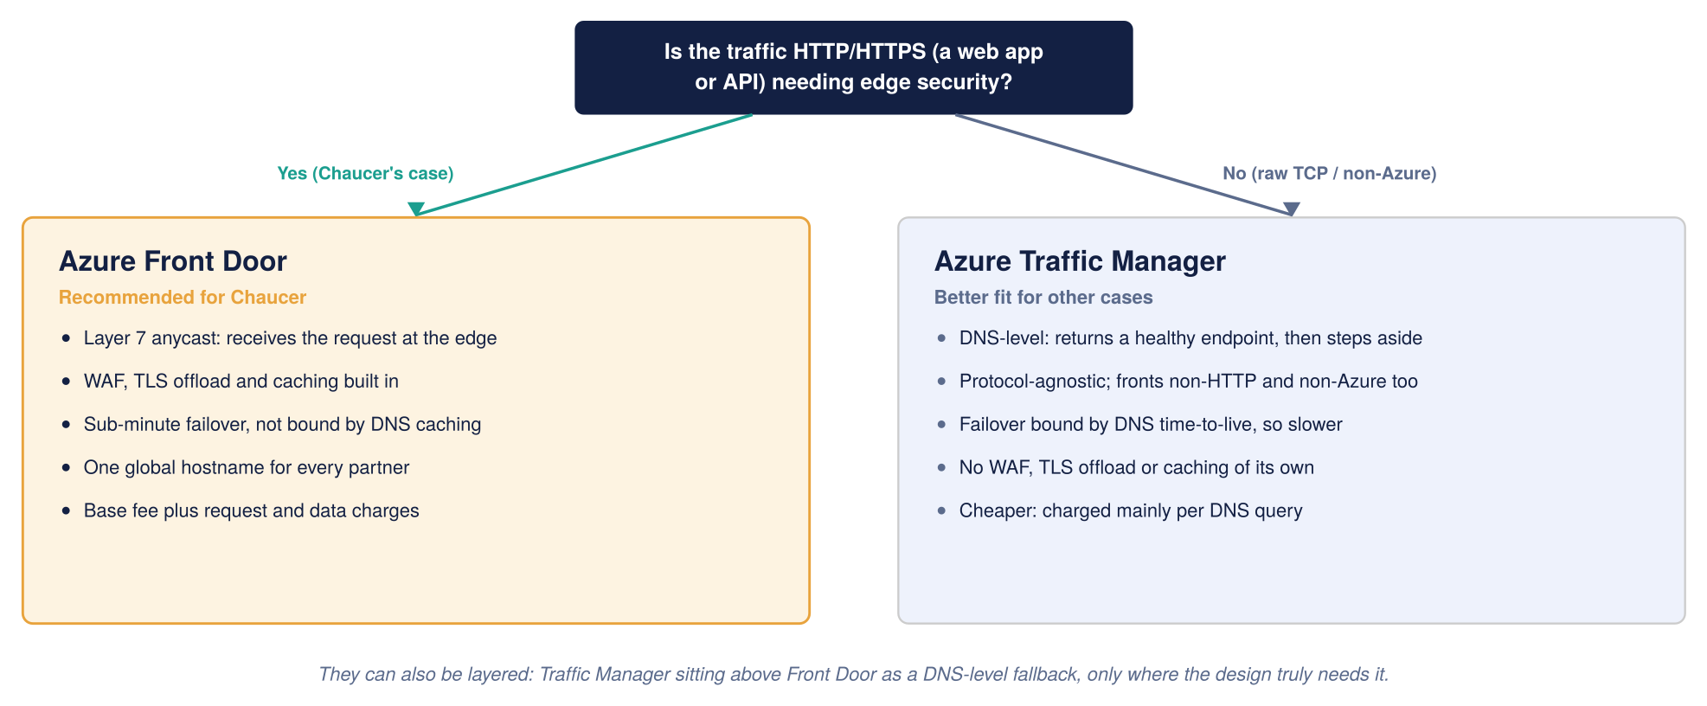
Global routing, Front Door compared with Traffic Manager

Network Topology and Connectivity Design
This section operationalizes the core design choices established and justified in Section 2 specifically the selection of Azure Front Door Premium with WAF as the edge perimeter and APIM deployed in Internal (VNet) Mode. by detailing the concrete network topology required to implement them.

It describes how traffic reaches APIM (the ingress path) and how APIM reaches out (the egress path), how the Palo Alto firewall fits in and which flows pass through it, and the routing and subnet design that underpins all of it. The step-by-step configuration of each flow is detailed at the end.

Ingress flow
Azure Front Door + WAF with Internal APIM - The selected entry pattern positions Azure Front Door + WAF in front of an internal-mode APIM instance (Option A). Across all options evaluated, APIM remains strictly in internal mode and is never exposed to the internet; the only difference lies in the edge service. The complete decision framework and option comparisons are detailed in Section 2 (Edge Service Selection).
This diagram shows the inbound (ingress) request flow, how a request travels from a consumer through the edge and APIM to the backend.
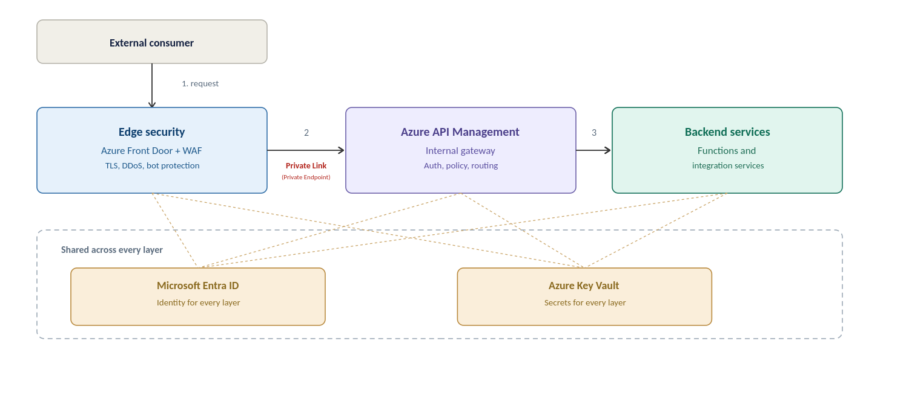
High-level Azure APIM architecture for the Organization

Egress flow
This diagram shows the outbound (egress) traffic flow, how APIM and backends reach external third-party APIs through the Palo Alto firewall.
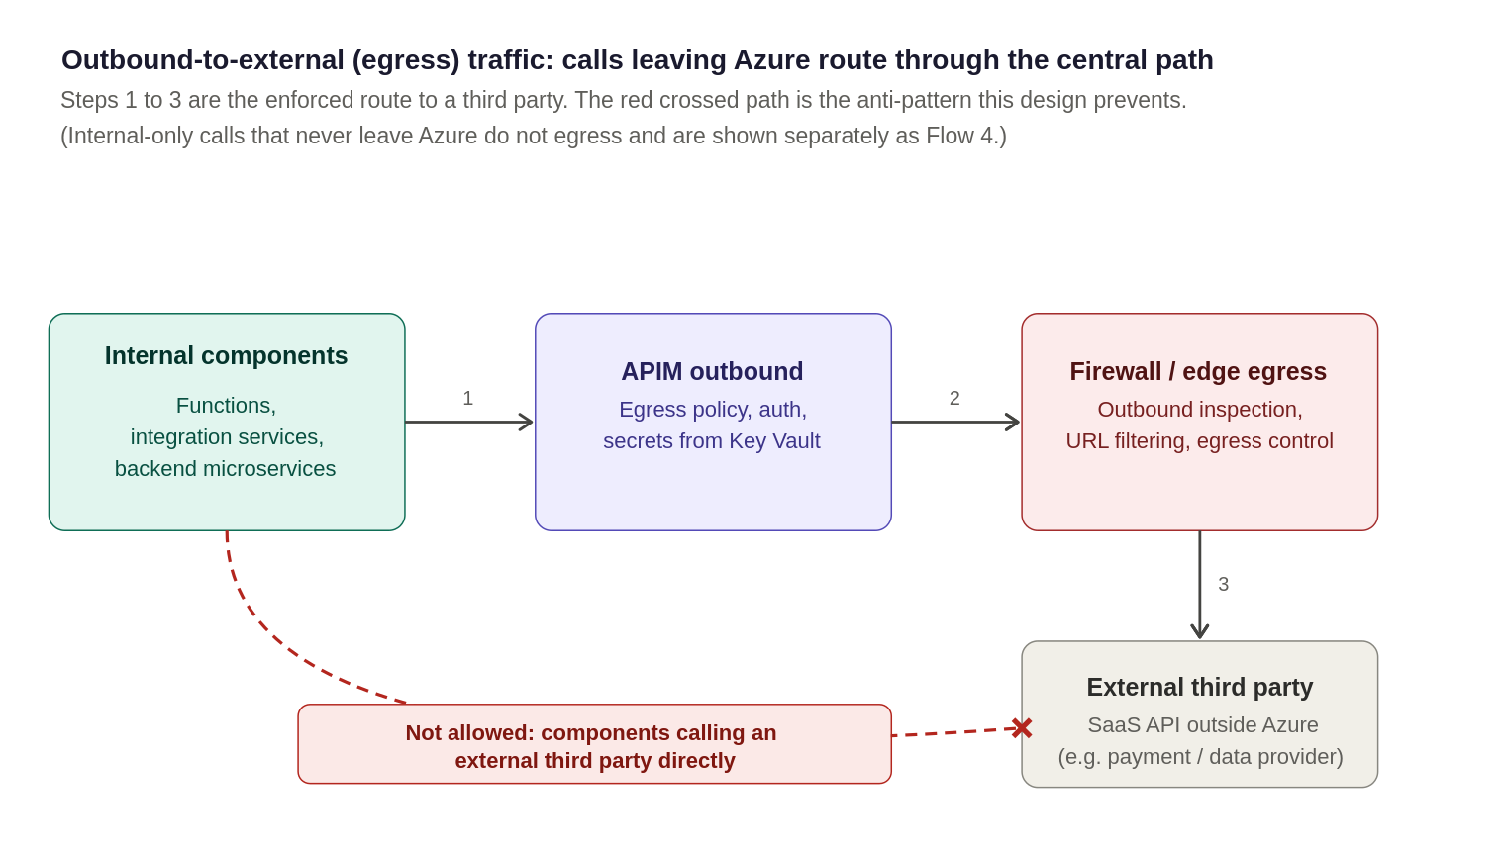
Outbound-to-external (egress) traffic, calls leaving Azure to a third-party route through the central egress path

Egress Control
- Approved outbound endpoints documented per API.
- All outbound traffic is logged and auditable at firewall
- Premium V2 isolates platform dependencies from Chaucer VNet and no firewall exemptions required

Firewall integration
The Organization uses Palo Alto as its egress firewall. In this design it inspects and controls outbound traffic to external third parties only: inbound traffic enters through Front Door over Private Link and does not traverse the firewall, and internal-only calls stay on the private network. The egress flow is further described under "Traffic flows in detail" at the end of this section.

Topology and the guiding principle
The Palo Alto egress firewall sits in the hub APIM sits in a delegated subnet in a spoke VNet, peered to the hub, and runs in internal mode so its data-plane gateway has a private virtual IP and no public data-plane address. Routing intent sends outbound traffic destined for external third parties to the Palo Alto for inspection. The guiding principle is that outbound traffic leaving Azure to a third party is inspected by the Palo Alto, while inbound traffic (through Front Door) and internal-only traffic stay off the firewall.

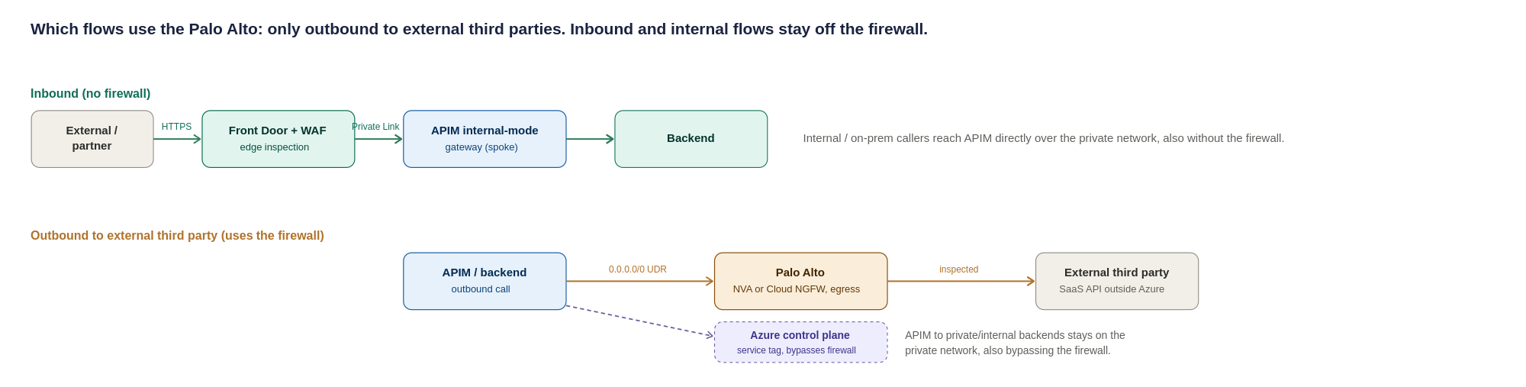
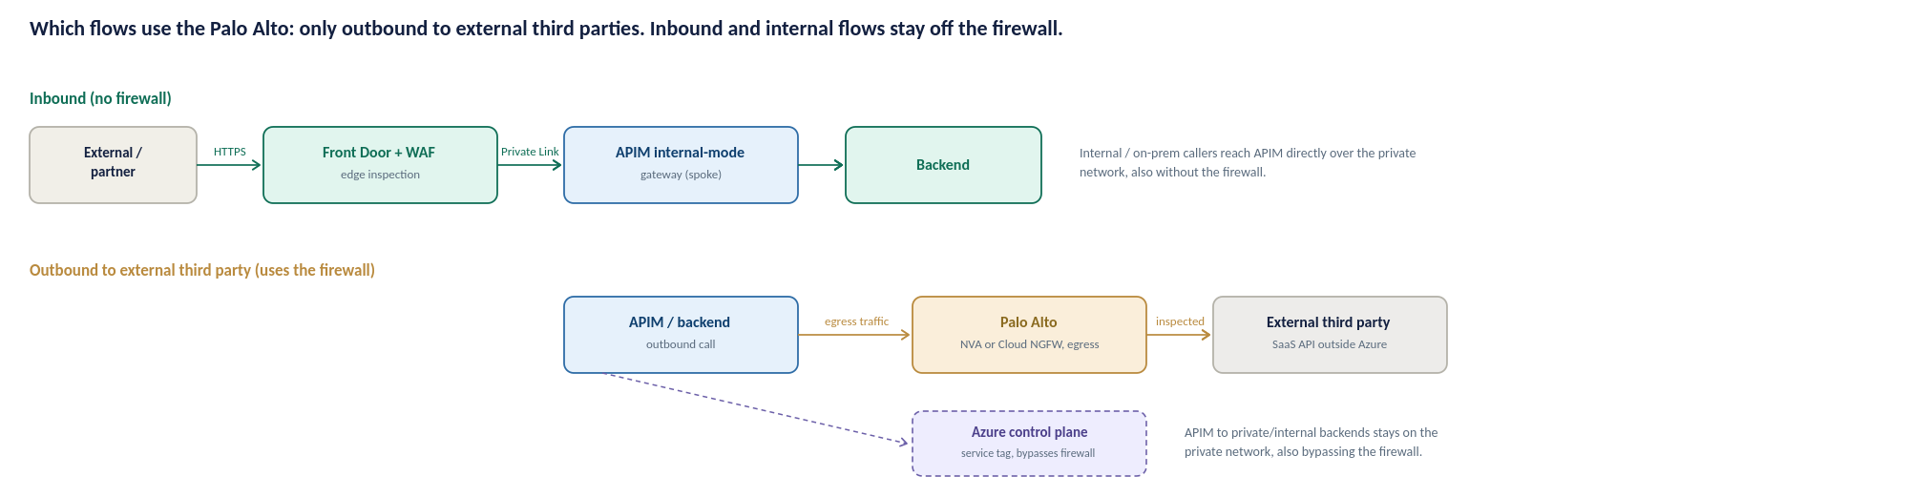
Figure 10: Which flows use the Palo Alto, only outbound traffic to external third parties; inbound (Front Door/Private Link) and internal flows stay off the firewall
Summary of which flows use the firewall:
Traffic flow | Through Palo Alto? | How it is secured
External inbound (via Front Door) | No, bypasses the firewall by design | Front Door WAF at the edge; origin locked to Front Door (Private Link + NSG + X-Azure-FDID)
Internal inbound | No, stays on the private network | Reaches the APIM internal gateway directly over peering/ExpressRoute; authenticated and policy-checked at APIM
Outbound to external third party | Yes | Routing Intent redirects traffic to the Palo Alto; egress inspection and URL-filtering policy
APIM to private / internal backend | Yes | Private Endpoint + NSG, stays on the Azure backbone, does not traverse the firewall, East-West Traffic in UK South flow through Firewall.

Traffic flows in detail
This subsection elaborates the four main traffic flows possible in the estate.. The summary table in section 6.3 provides a quick reference and this provides some further details.
Flow 1: External inbound
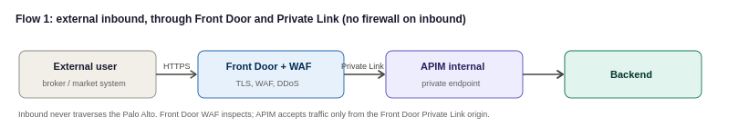
An external consumer, reaches the Organization over the internet. Traffic lands at Azure Front Door, where the WAF, TLS termination and DDoS protection are applied, and Front Door forwards the validated request to APIM over a Private Link inbound private endpoint. Because APIM is internal-mode it has no public endpoint; the only way in is through Front Door over Private Link. Inbound traffic does not traverse the Palo Alto firewall, which is an egress control mechanism.
- Front Door: WAF (OWASP + bot rules), TLS termination and DDoS protection at the edge; Private Link origin to the APIM inbound private endpoint.
- APIM subnet NSG: allow inbound only from the Front Door Private Link path; deny direct internet inbound. Origin locked to the Organization’s Front Door instance (Private Link approval + X-Azure-FDID header verification).
- No firewall on this path: the return path is symmetric because Front Door and APIM communicate over Private Link on the Azure backbone, with no NVA in the middle.
Flow 2: Internal Inbound
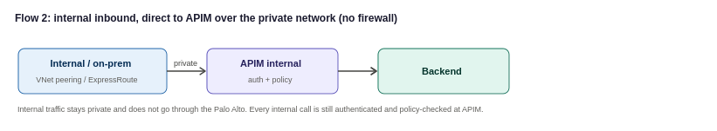
An internal Organization system, or an on-premises system reaching Azure over ExpressRoute or VPN, calls an internal API. The call reaches the APIM internal gateway directly over the private network (VNet peering, or ExpressRoute/VPN for on-premises), and APIM applies authentication and policy before forwarding to the backend. Internal traffic stays on the private network and does not traverse the Palo Alto, which handles egress to external third parties only. Internal consumers still never bypass the gateway: every internal call is authenticated and policy-checked at APIM, in line with the zero-trust principle in the security section.
Flow 3: Outbound
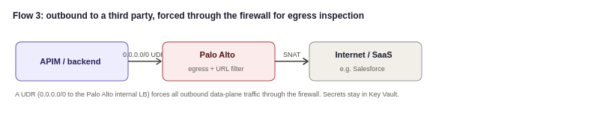
When APIM or a backend needs to call out, to a public SaaS provider such as Salesforce, or to any internet endpoint, that traffic must be inspected on the way out. Routing intent forces all outbound data-plane traffic through the firewall, where egress policy and threat prevention apply. This is the flow that gives the Organization the outbound inspection and audit it runs the Palo Alto for in the first place.
- Routing Intent: Azure Routing Intent is enabled to direct APIM traffic through the central Palo Alto firewall, ensuring both north-south and east-west traffic flows are subject to centralized inspection, policy enforcement, and monitoring.

- Palo Alto: outbound security and URL-filtering policy for the destinations APIM is permitted to reach; SNAT as required.
- Credentials for SaaS calls stay in Key Vault-backed named values; the firewall controls the path.
Flow 4: APIM to private backends
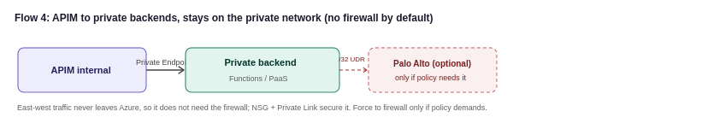
Calls from APIM to backends that live inside the Organization’s own network, integration services and Functions, or PaaS reached over Private Endpoint, stay on the private network. East-west traffic is routed through the central firewall using Azure Routing Intent. This ensures traffic between platform components is consistently subject to security inspection, policy enforcement, and monitoring before reaching its destination, providing a uniform security posture across the environment.

Configurations
This section demonstrates sample configurations for Azure front door and APIM Instance

6.6.1 Azure Front Door

6.6.2 APIM Instance Composition
Following the APIM tier selection in Section 3.4, this section describes the proposed target configuration for the APIM platform, including service tier, regional deployment, network mode, custom domains, TLS, and identity. The values shown represent the target-state design; custom domains are illustrative, and regional and networking choices remain subject to alignment with Chaucer's landing zone and naming standards.
Attribute | Proposed value | Status | Technical Rationale
Service Tier | Premium v2 | Proposed | Unlocks v2 architecture benefits, eliminates legacy cloud service (Classic) dependencies.
Region | UK South | Strategic | Deployed as in regional instances orchestrated via Azure Front Door.
Availability Zones | Zone-Redundant – 2 zone | Proposed | Deployed across 2 Availability Zones within single region.
Networking Mode | VNet Injection & Private Endpoints | Proposed | Standard v2 private networking pattern (Inbound via Private Endpoints, Outbound via VNet Integration subnet).
Custom domain | api.organization.com (external), api-internal.organization.com (internal) | Dummy placeholder | Domain names map to Front Door (External) and Private IP / Internal DNS (Internal).
TLS | TLS 1.2 Minimum | Proposed standard | Enforces TLS 1.2+ minimum across all endpoints, legacy ciphers disabled by policy.
Managed identity | User-Assigned Managed Identity | Proposed | Enables resilient, cross-resource access to Azure Key Vault and Azure Monitor without lifecycle coupling.
Developer Portal | Internal-Only | Proposed | Public access disabled, access restricted via internal VNet routing or Entra ID SSO.

The service scales in units, each a fixed block of gateway capacity. Production runs zone-redundant across Availability Zones and adds units as sustained traffic requires, rather than over-provisioning up front the capacity and cost model behind this is in section 15. The instance is deployed and changed only through code and pipelines, so its configuration is reproducible and auditable, as described in section 13.

6.6.3 Routing and subnet design

Path / Flow Type | Where enforced | Routing & Security Policy Rule
External Inbound | Front Door + WAF (Edge) | WAF inspection, TLS offloading, and DDoS mitigation at the edge. Front Door routes to APIM via Private Link Origin (Private Endpoint). Subnet NSG denies direct public internet ingress.
Internal Inbound | APIM (Private Network) | Reaches APIM internal gateway directly over VNet Peering or ExpressRoute. Authenticated and policy-checked at APIM without traversing the perimeter firewall.
Outbound to External 3rd Party | Routing Intent + Palo Alto Firewall | Routing Intent redirects outbound traffic to Palo Alto firewall; egress inspection, domain filtering, and threat protection on the firewall.
APIM to Private / Internal Backend | NSG + Private Endpoint | Private path stays strictly on the Azure backbone via Private Endpoints or VNet integration
Control Plane (Mandatory) | APIM v2 Managed Platform | APIM Premium v2 native behaviour: control plane management traffic flows securely over internal Microsoft platform infrastructure. Inbound management ports and explicit Api Management UDRs are not required.
Platform Dependencies | Network Security Controls | APIM Premium v2 relies on several Azure platform services, including Azure Monitor, Key Vault, and Storage. Connectivity to these services must be permitted through the organization's network security controls to support normal platform operation.

Proposed Subnet sizing (to confirm against the landing zone)
Sizing the APIM delegated subnet and its neighbours correctly the first time avoids a disruptive resize later, since an Azure subnet cannot easily be shrunk or re-carved once resources are deployed into it. The figures below are starting points for detailed design, not a final IP plan; the actual VNet address space must come from the Organization’s IPAM and hub-spoke allocation.
Subnet | Minimum size | Why
APIM delegated subnet (Premium V2, VNet injection) | /27 (32 addresses) per region as an absolute floor; /26 recommended | APIM Premium v2 consumes a portion of subnet address space for platform services and scaling operations. A /26 subnet provides adequate capacity for future scale-out and is the recommended default, whereas a /27 subnet offers limited growth headroom.
Application Gateway subnet (if Option B/C is used) | /26 recommended, /27 minimum | Autoscaling instances each consume an address, under sizing blocks scale-out under load
Palo Alto internal load balancer / hub subnet | Per the Organization’s existing hub design | Owned by the network team; not part of this HLD’s sizing, referenced here for completeness
Private Endpoint subnet(s) for backends | /27 per subnet is usually sufficient | One address per Private Endpoint; size to the number of backend services expected, with headroom

Network artefact | Requirement | Owner
NSG: gateway | Allow 443 from the Front Door Private Link path and internal ranges only; deny the Internet service tag | Network
DNAT (not used) | Not used in this design: inbound arrives via Front Door Private Link, not a firewall public VIP | Network
Private DNS | Do NOT create a Private DNS zone for azure-api.net. Create explicit A records mapping each APIM endpoint FQDN to the private VIP, resolvable from all VNets and on-prem networks that need access | Platform + Network
Backend DNS resolution | Azure Private DNS Resolver with forwarding rulesets for APIM-to-on-prem backend name resolution | Network
ExpressRoute / VPN return-path symmetry | Ensure symmetric routing for on-prem consumers reaching the internal VIP: UDRs and firewall rules must be consistent on both the Azure and on-prem sides so return traffic follows the forward path | Network

Security and Authentication Design
Security is the foundational principle of this architecture. Access is explicitly validated at every hop and never assumed based on network location or prior perimeter checks—traffic originating from within the internal network is subject to the exact same verification standard as external requests.
A single security control failure must never expose a backend service. Each request passes through a mandatory, ordered sequence of defence-in-depth controls before reaching downstream targets:
- Perimeter & Edge Protection: Mitigates volumetric attacks and inspects web application firewalls (WAF).
- Identity & Access Management: Validates caller identity (Microsoft Entra ID / OAuth 2.0 / Mutual TLS).
- Gateway Policy Enforcement: Applies schema validation, scope authorization, rate limits, and throttling.
- Isolated Network Routing: Ensures traffic travels strictly via Private Endpoints and internal VNet injection.

Security
The access models in sections 5.3 and 5.4 rely on four security pillars applied consistently across the platform:
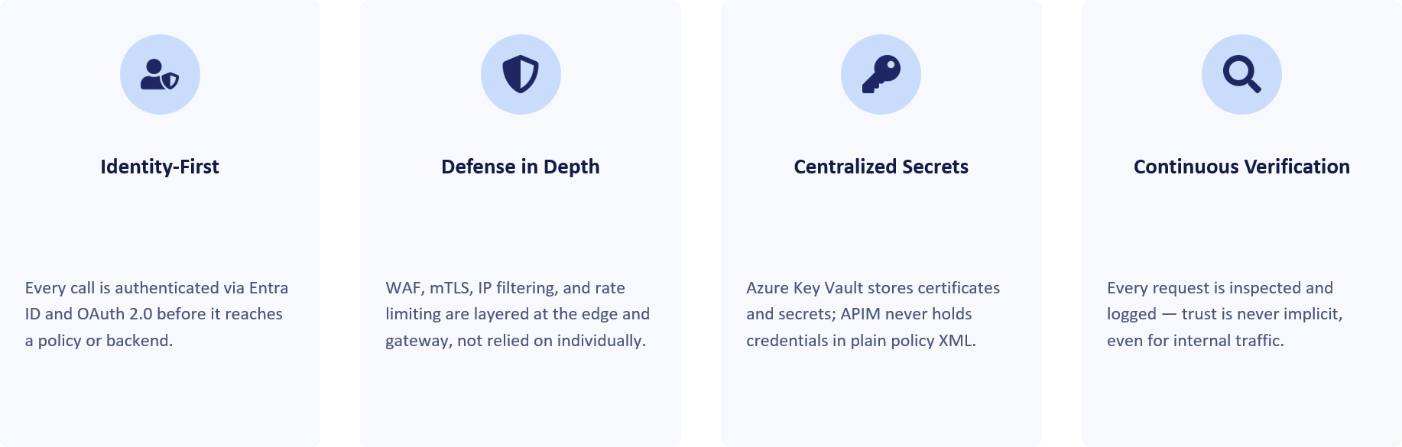
Security architecture: defence in depth at a glance
The diagram below illustrates the defence-in-depth model for a private-mode APIM deployment protected by an edge security service. Requests traverse multiple control layers before reaching backend services, with each layer applying a specific security function. Security is achieved through the combined operation of all layers rather than reliance on any single control.

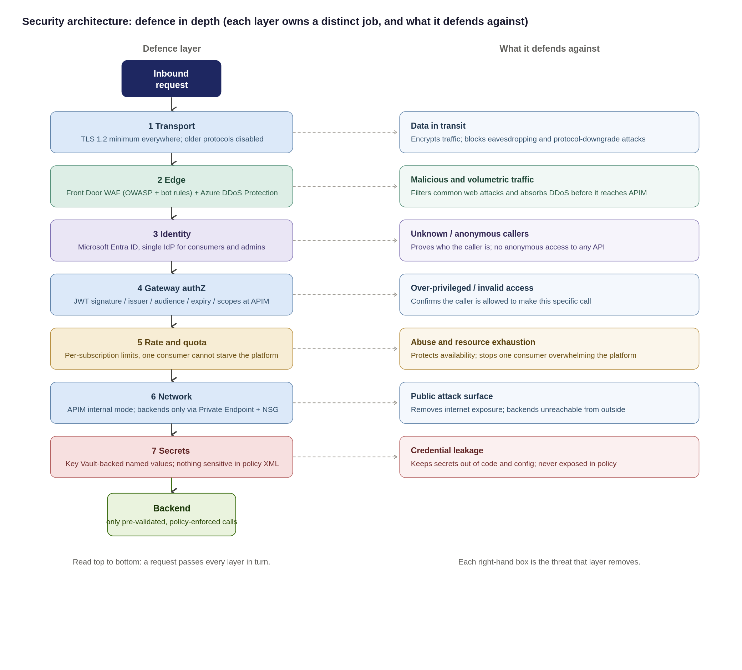
Security design principles
The controls detailed in this section enforce seven foundational security principles across the platform:
- Verify Explicitly (Zero-Trust): Validate every hop independently; no request is trusted simply because it originates from within the corporate network.
- Defence-in-Depth: No single control is load-bearing; security relies on layered edge WAF, gateway policies, and network isolation working in unison.
- Least Privilege: Consumers, APIOps deployment pipelines, and administrators are granted the minimum permissions necessary to perform their roles.
- Secure & Deny by Default: All APIs remain private and unauthenticated by default until explicitly configured and approved for publication.
- Single Identity Provider: Microsoft Entra ID serves as the central Identity Provider (IdP) for both consumer OAuth validation and platform administration.
- Everything as Code (APIOps): Platform and API security configurations are version-controlled, peer-reviewed, and deployed exclusively via automated pipelines.
- Zero Secrets in Code: No credentials or secrets are committed to repositories or hard-coded in policies all use Key Vault-backed Named Values
<Refer Primary ref here >
Residual Risk & Mitigation Matrix
Residual risks remain after the application of the defined controls. The table below identifies those risks, the associated compensating controls and the accountable owner to ensure they are explicitly understood, managed and tracked.
Residual Risk | Risk Rationale & Root Cause | Compensating Control & Mitigation Strategy | Risk Owner
Backend Object-Level Authorization (BOLA / OWASP API1) | APIM validates token signature and passes claims, but only the downstream domain service understands its internal domain object model. | Mandatory domain backend-authorization standard, static code review, and automated contract testing per API. | Domain Teams
Non-OAuth Exception Consumers | Legacy partners or constrained systems that cannot support modern OAuth 2.0 / OIDC authentication flows. | mTLS or static IP allow-listing combined with short-lived rotating secrets; enforced via time-boxed, reviewed security exception. | Security
Unverified Compliance Control Mapping | The Organization control catalogue has not yet been cross-checked and independently audited against this design. | Formal compliance sign-off of the Control-to-Evidence Matrix prior to passing the final Go-Live gate. | Compliance
Peak Load Capacity Behaviour | Exact peak request-per-second (RPS) metrics have not been benchmarked under real production conditions. | Mandatory pre-go-live performance/load testing; dynamic autoscaling based on gateway CPU and memory metrics. | Platform Team
Single Gateway Ingress Concentration | A multi-tenant shared platform concentrates blast radius compared to isolated, scattered backend endpoints. | Rate limiting, , multi-region Front Door routing, WAF/DDoS, and Emergency Administrative Access runbooks. | Platform & Security

Threat model: STRIDE and the OWASP API Security Top 10
To ensure comprehensive coverage, the platform security model is evaluated against two complementary frameworks:
- STRIDE: Evaluates platform and infrastructure-level threat vectors (Spoofing, Tampering, Repudiation, Information Disclosure, Denial of Service, Elevation of Privilege).
- OWASP API Security Top 10: Addresses API-specific application vulnerabilities (BOLA, Broken Authentication, Mass Assignment, Unmanaged APIs).
Threat Vector & Key Risk Area | Framework Mapping | Architectural Control & Enforcement Strategy
Identity Spoofing & Broken Authentication | STRIDE: Spoofing  OWASP: API2:2023 | Mandatory Microsoft Entra ID OAuth 2.0 / JWT validation at gateway; strict claim inspection; mTLS and static IP allow-listing for authorized legacy exceptions.
Data Tampering & Payload Injection | STRIDE: Tampering  OWASP: API8:2023 | Enforcement of TLS 1.2+ end-to-end; edge Azure Front Door WAF rulesets; strict OpenAPI request schema validation at gateway ingress.
Repudiation & Audit Gaps | STRIDE: Repudiation  OWASP: API10:2023 | Centralized, immutable Azure Monitor / Log Analytics audit trail for all management and control plane actions; structured APIOps deployment logging.
Information Disclosure & Secret Exposure | STRIDE: Info Disclosure  OWASP: API3:2023 | Strict Private Endpoints / VNet isolation; zero plain-text secrets in policies (Azure Key Vault-backed Named Values); payload logging disabled by default with strict PII redaction rules.
Denial of Service & Resource Exhaustion | STRIDE: Denial of Service  OWASP: API4:2023 | Edge Azure DDoS Protection; per-subscription rate limits and quotas; dynamic gateway autoscaling based on CPU/Memory thresholds.
Broken Authorization (BOLA / BFLA) | STRIDE: Elevation of Privilege  OWASP: API1 & API5:2023 | Shared Responsibility Boundary: APIM validates caller identity/scopes and forwards claims. Downstream domain backends must enforce object-level and function-level authorization checks.
Shadow / Unmanaged API Proliferation | STRIDE: All Categories  OWASP: API9:2023 | Single ingress path via central APIM catalogue;; mandatory metadata tagging (audience, lifecycle status, data sensitivity); structured APIOps deprecation pipelines.

Data Classification, Payload Logging and PII
Because the gateway processes bearer tokens, sensitive header claims, and business payloads, strict data handling rules must be enforced across all environments. The platform position enforces three core tenets: classify data at onboarding, disable body logging by default, and keep telemetry free of personally identifiable information (PII).
Focus Area | Architecture Position & Governance Rule | Technical Enforcement Mechanism
Data Classification | Every API must be tagged at onboarding with its highest data sensitivity tier: Public, Internal, Confidential (PII), or Restricted (Special-Category / High-Value). | Enforced via APIM Tags, dictates required product subscriptions, encryption levels, and logging verbosity.
Payload & Body Logging | Request and response bodies are not logged by default in any environment. Diagnostic payload logging requires sensitive field masking and is strictly time-boxed. | Managed via APIM <log-to-analytics> policies with regex field masking. Verbose logging auto-expires (max 48 hours).
Correlation & Telemetry | All logs, metrics, and trace spans must use opaque correlation identifiers (trace parent, X-Correlation-ID). PII is strictly prohibited in telemetry attributes. | System generates random UUIDs. Sensitive identifiers (emails, account numbers) are stripped at gateway ingress.
Secrets Exclusion | Bearer tokens, API keys, and Key Vault secret references must never be captured in diagnostic or gateway log output. | Header stripping policies sanitize Authorization (Bearer ***) and Ocp-Apim-Subscription-Key headers before logging.
Data Retention | Log retention balances investigation capabilities against UK GDPR / DPA 2018 data-minimization and storage limitation rules. | Default Log Analytics workspace retention set to 30 days (interactive), offloading to immutable storage for compliance.

Exception process for non-OAuth consumers
OAuth 2.0 with Entra ID is the default authentication standard. Where a partner cannot support this approach, an approved exception may be granted. Exceptions must be documented, risk-assessed, supported by compensating controls, time-bound and subject to periodic review.

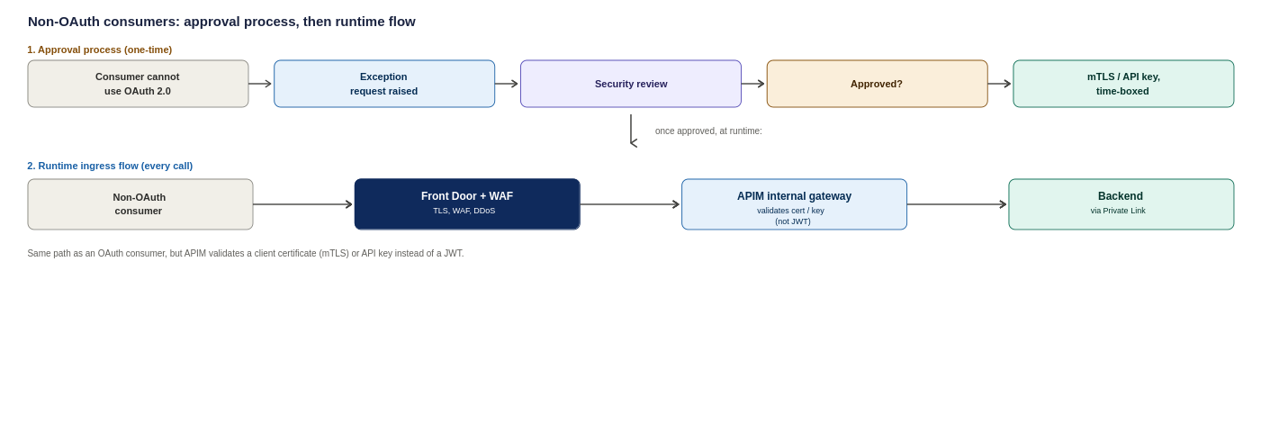
Figure 11: Non-OAuth consumers, the one-time approval process and the resulting runtime ingress flow
How each consumer type proves who they are
Consumer | Primary Authentication Method | Secondary / Compensating Control
External partner | OAuth 2.0 token issued by Entra ID and validated at APIM | Subscription key, IP allow-list where fixed egress IPs exist
Internal Organization system | Managed Identity (no stored credentials) | Entra ID conditional access on the calling service
Inbound webhook from a vendor | Shared secret header, checked against Key Vault | IP allow-list restricting the source range

Control Responsibilities
Security controls are implemented as a layered model and are not interchangeable. Each control addresses a specific security concern, and the overall security posture depends on the combined operation of all controls rather than reliance on any single mechanism.
Control | Primary responsibility
Microsoft Entra ID | Identity and authentication
OAuth 2.0 / JWT | Authorisation context per request
APIM | API gateway and policy enforcement
WAF (Front Door / App Gateway) | HTTP and API-layer attack protection
Azure DDoS Protection | Volumetric and network DDoS
Azure Firewall / NVA | Network segmentation and egress control
Private Endpoint | Private connectivity to backends
the Organization’s SIEM | Detection and investigation
APIM policies | Rate limits, quotas, validation, transformation

Partner and External Identity
The Organisation's external consumers include brokers, market participants, strategic partners, suppliers and third-party service providers. Authentication and onboarding approaches may vary by consumer type and technical capability.
- Preferred approach: External organisations are represented through Microsoft Entra External ID (B2B) using partner-specific application registrations and controlled access assignments.
- Approved alternatives: Where Entra-based integration is not supported, approved federated identity, OAuth 2.0, mTLS, HMAC-signed requests or other approved authentication mechanisms may be used through the exception process.
- Governance requirement: Partner onboarding, application registration, credential and certificate lifecycle management, access reviews, rotation and revocation responsibilities must be defined and owned by the appropriate Identity and Access Management function before implementation.

Identity Resilience and Break-Glass
The platform relies heavily on Entra ID and must remain operational during identity-service outages or administrative-access incidents. To support this, the following controls must be defined and maintained:
- Break-glass access: Emergency-access accounts with monitored and audited use, held outside normal access-management processes.
- Credential lifecycle monitoring :Proactive monitoring of certificate and secret expiry, including automated alerting.
- Partner credential revocation: Defined processes for partner credential suspension, rotation and revocation.
Application registration ownership: Clear ownership and lifecycle management for application registrations and associated identities.

Authentication

7.2.1 OAuth 2.0 Authentication Flow
This is the detailed token exchange behind the authentication step referenced in sections 5.3 and 5.4, shown here as the standard OAuth 2.0 sequence APIM enforces on every call.
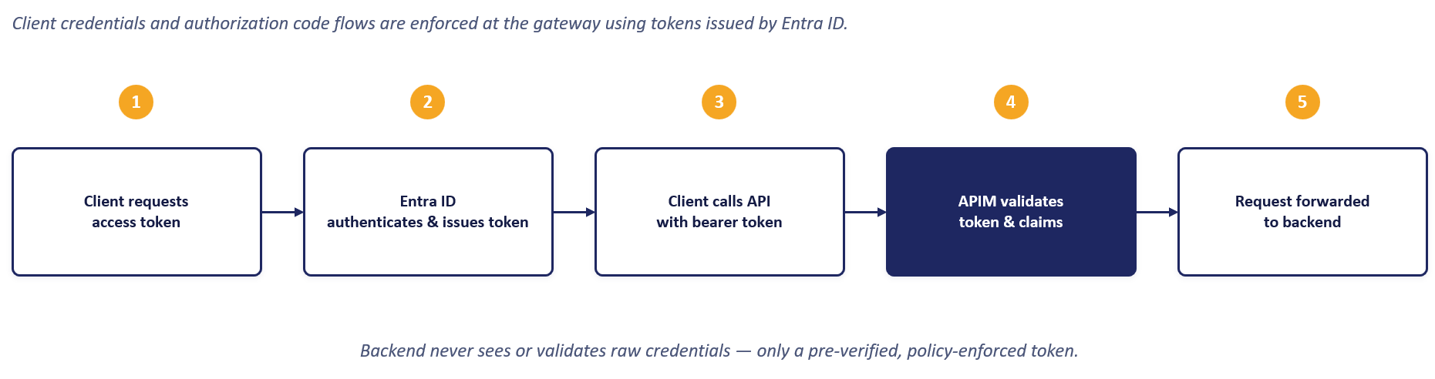

7.2.2 JWT Validation Flow
Token validation is performed independently of client authentication. APIM validates incoming JWT bearer tokens against the configured issuer, audience, signature and expiry requirements before the request is processed.
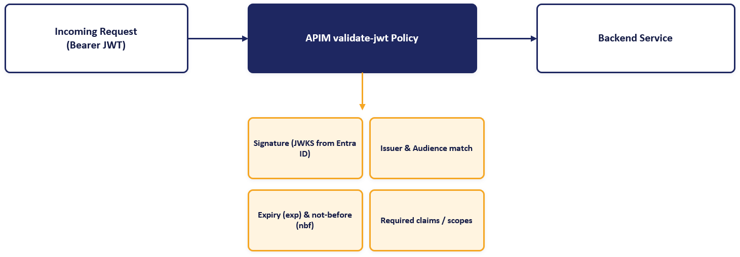

7.2.3 APIM and Entra ID Integration
Microsoft Entra ID provides the foundation for platform identity and access management. It supports client authentication, application registration, token issuance, administrative access control and the managed identities used by APIM to securely access backend services and Azure Key Vault.
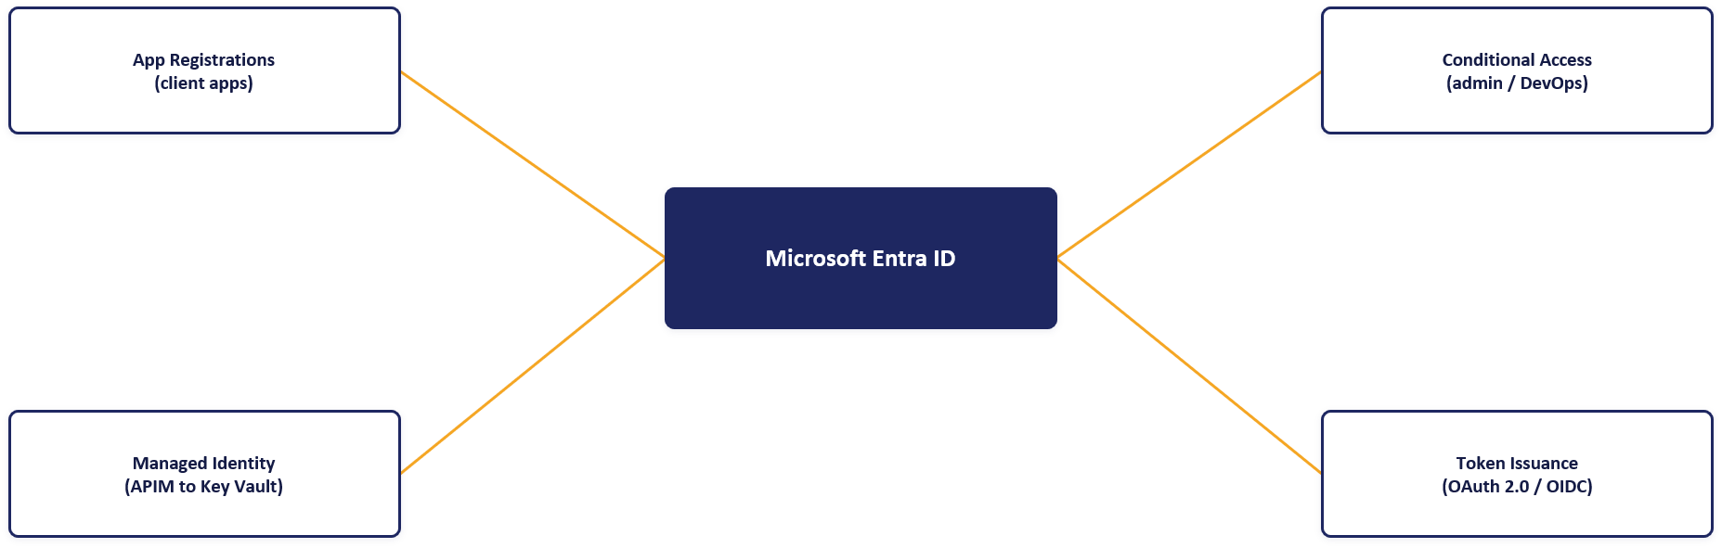

7.2.4 Secrets and Certificates Management
The preferred implementation is that APIM does not store application secrets locally. Required certificates, keys and credentials are retrieved from Azure Key Vault at runtime using the APIM managed identity.
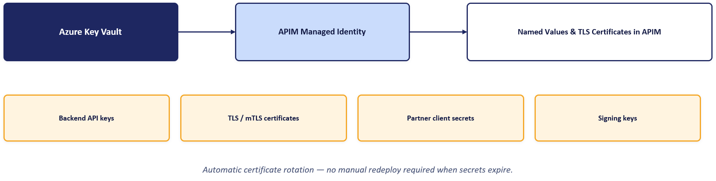

7.2.5 Zero Trust API Security
These three principles extend the access models above to every call, including internal traffic, which is never trusted by default.
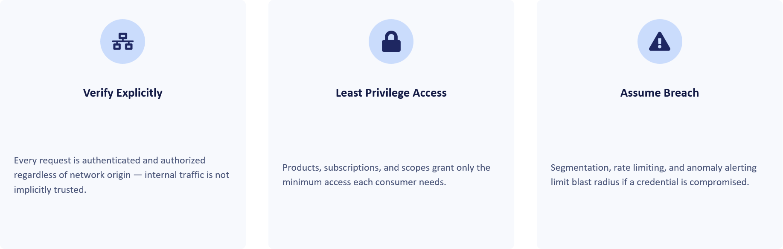

API Product, Consumer and Developer Portal Model
API platform governance requires clear separation of ownership while maintaining centralised visibility and control. Workspaces provide logical isolation between teams, while products, subscriptions and Microsoft Entra ID groups control API exposure, access and administration. This approach enables decentralised API ownership within a centrally governed platform.

Choosing each layer: a clear strategy for Products, Consumers and the Portal
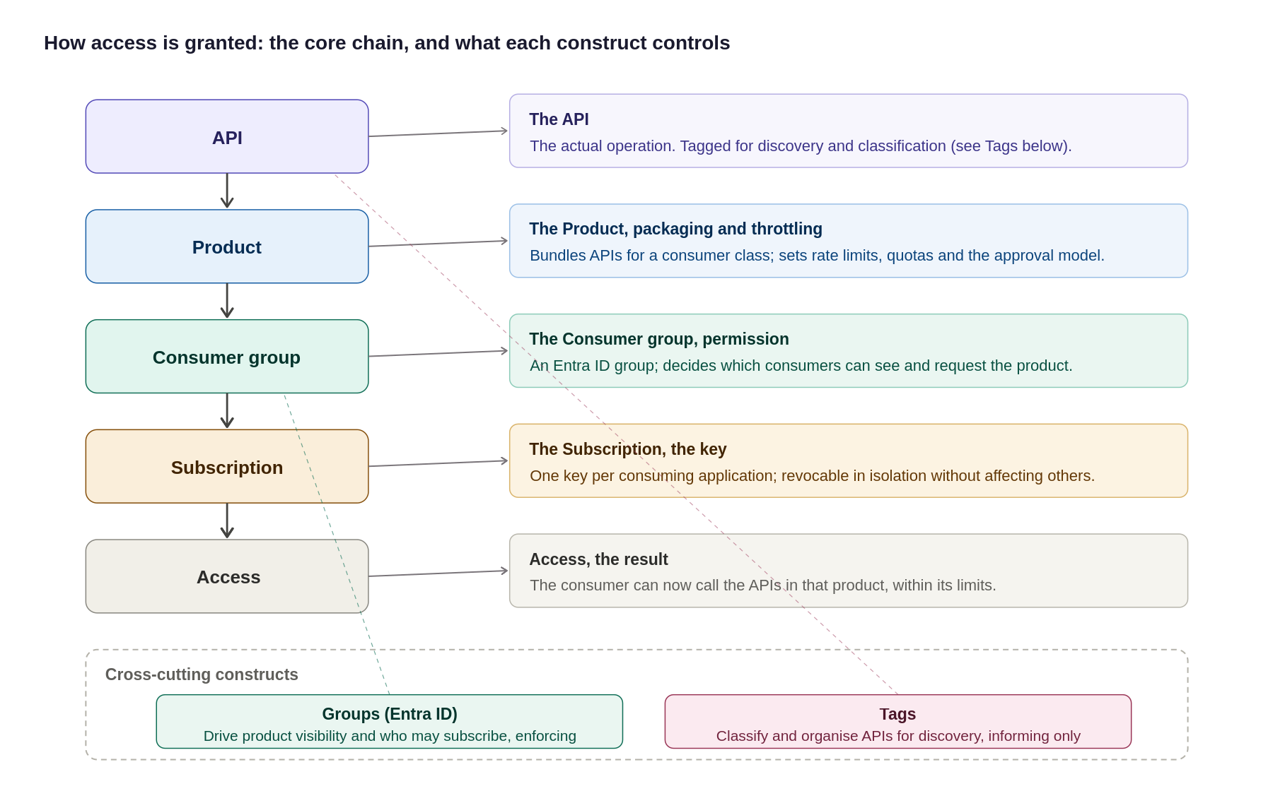
Figure 17: The access model, the core chain plus what each construct controls, including Groups and Tags
In summary:
Layer | Purpose | Recommended Approach
Product | Which APIs a consumer can access and under what controls | Group APIs into products by consumer type. Apply policies, quotas and approval controls at product level.
Consumer / subscription | How access is granted, managed and revoked | Use Entra ID groups for organisational ownership and separate subscriptions per consuming application. Avoid local APIM users.
Developer portal | How consumers discover, subscribe to and test APIs | Enable SSO, disable self-registration and expose APIs through a governed product catalogue with controlled visibility.

The diagram below illustrates the APIM governance hierarchy and access model. APIs are grouped into products, consumers are authorised through subscriptions, and access is governed through Microsoft Entra ID groups and RBAC controls..
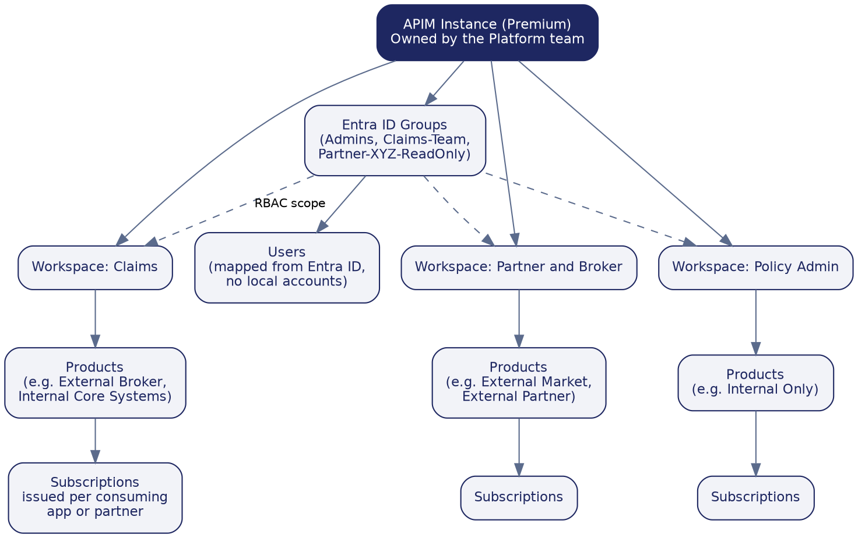
Figure 18: Recommended workspace, product, subscription, and group structure

Products, subscriptions, groups and users
- Products group related APIs and define access, subscription and policy boundaries for a consumer class..
- Subscriptions are issued per consuming application or partner, allowing access to be managed, rotated or revoked independently..
- Groups map to Microsoft Entra ID groups and control visibility and access to APIs and products.
- Users are authenticated through Microsoft Entra ID. APIM access is governed through group membership and the organisation's existing identity lifecycle processes..
Governance Construct | Core Purpose & Architectural Behaviour | Key Governance Rule & Enforcement
Backends | Abstracts downstream target URLs and centralizes runtime resilience rules (circuit breaking, load balancing, retries). | Target URLs and health check policies are managed centrally outside individual API definitions.
Named Values | Provides APIM's key-value store for plain settings (URLs, limits) and Key Vault-backed secret references. | Zero secrets hard-coded in policies. All secrets use Key Vault integration and are version-controlled via APIOps.
Policies | Enforces execution logic, transformations, authentication, and rate limits at global, product, or API scopes. | Policies reference Named Values for config; product-level policies enforce class-wide rules once.
Products | Group APIs into consumable offerings with common access and subscription controls. | Consumers subscribe to products rather than individual APIs.
Groups | Controls visibility and subscription access to Products based on user membership. | Custom groups map strictly to Microsoft Entra ID. No local user accounts are created inside APIM.
Tags | Provide categorisation, discovery and reporting metadata. | Tags support discovery and governance only and do not influence runtime behaviour.

How the Governance Constructs Fit Together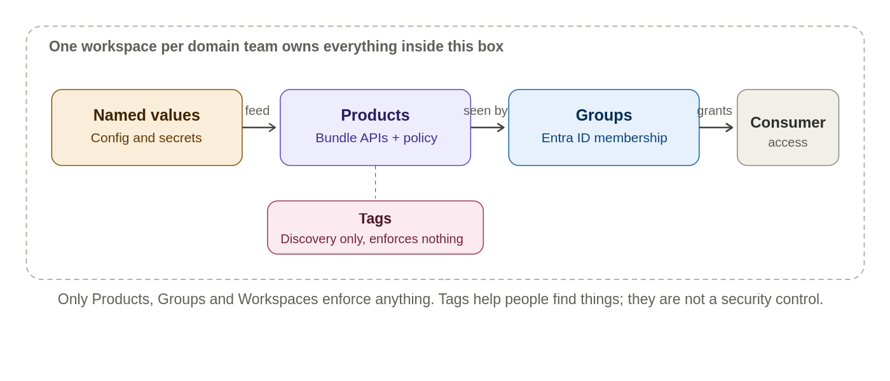
How the governance constructs relate to each other

Developer Portal
Purpose
The Azure APIM Developer Portal serves as the primary self-service interface for API consumers, publishing and automatically generated catalogue, interactive documentation, testing consoles, and automated subscription workflows. Its core objective is zero-touch onboarding—enabling internal and external developers to discover and adopt APIs without manual support tickets.
The platform distinguishes between two operational roles:
- API Publishers (Platform & Internal Teams): Operate exclusively via APIOps pipelines to deploy APIs, products, and policies into the management plane.
- API Consumers (Developers & Partners): Interact strictly through the Developer Portal to consume documentation, manage subscriptions, and generate access keys.
Reference architecture
The Developer Portal is hosted independently as a managed web application and is completely isolated from the gateway runtime path:
- Catalogue Publishing: The APIM management plane dynamically projects published APIs, schemas, and products onto the portal interface.
- Identity & Access Control: Authentication delegates directly to Microsoft Entra ID for internal workforce users and Entra ID B2B for external partners.
- Runtime Isolation: The portal handles metadata and subscription lifecycle only. Once a subscription key is issued, consumer application traffic bypasses the portal entirely, invoking the APIM Gateway directly where policy enforcement and security controls occur.

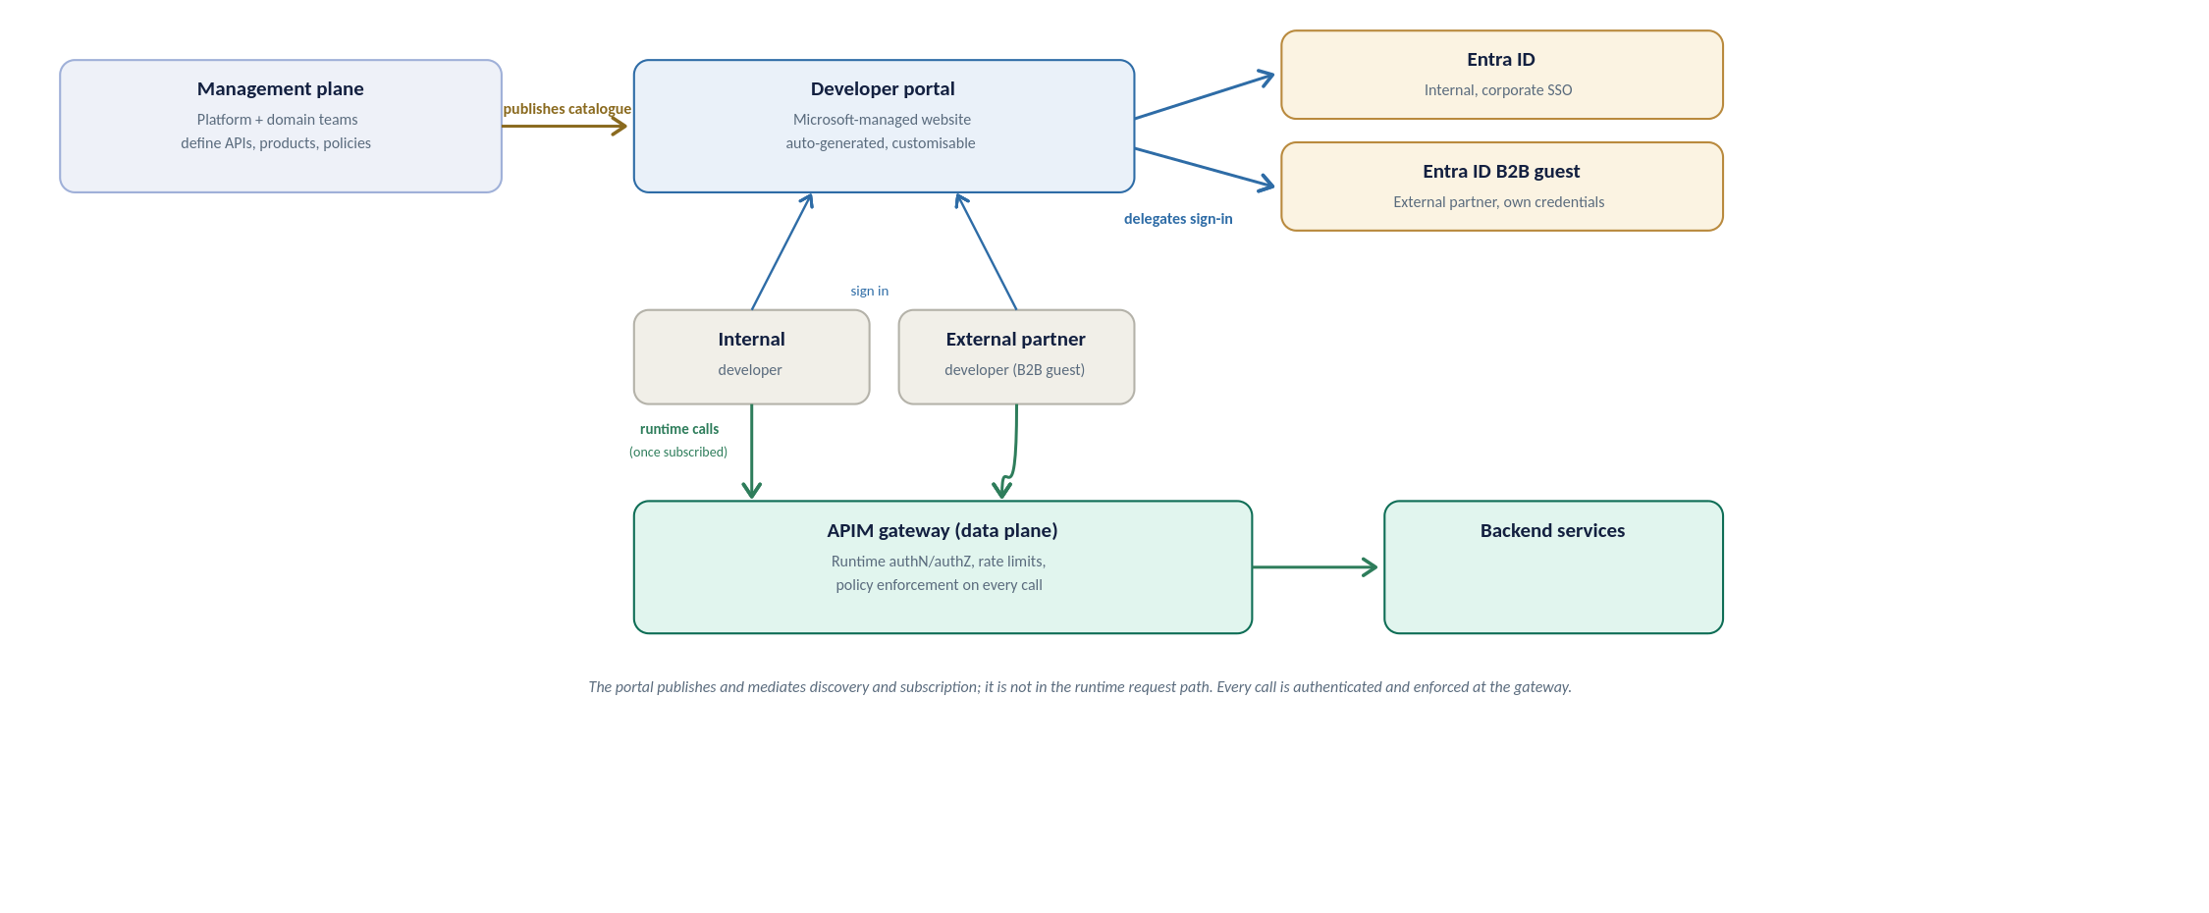
Developer portal reference architecture, how the portal relates to the management plane, identity providers, and the runtime gateway
API discovery strategy
Discovery is deliberately curated, not a raw API list. Three rules shape what a developer finds:
- Visibility follows identity: the portal shows only the products a signed-in developer’s Entra ID group permits, so a broker sees broker products and never an internal-only API.
- Grouping is by product, not raw API: a developer opens a product tile (for example External Broker), sees the APIs it bundles, and subscribes to the product as a unit; the subscription then works across every API in it.
- Tags are the search axis: consistent tags (section 10) let developers filter and search a growing catalogue, and each API page carries its operations, request and response schemas, and an interactive console for trying a call.
Built-in roles and RBAC
Two separate layers of access apply to the portal: who can see and use it as a consumer, and who can administer or publish its content. Neither creates a local account; both resolve back to Entra ID, consistent with the access model set out above.
Portal groups: who can see and use the portal
Group | Membership | What it grants
Administrators | Azure subscription administrators (system-managed) | Manages the APIM service and defines APIs, products and policies; not a consumer-facing role
Developers | Every signed-in, authenticated portal user (system-managed) | Base authenticated access; which products they actually see still comes from their Entra ID group
Guests | Anonymous portal visitors (system-managed) | Read-only browse of products marked visible to Guests; cannot subscribe or call an API
Custom / Entra ID groups | One per consumer class, for example Claims-Team or Partner-XYZ | Scopes visibility to the products that class of consumer may see, per the access model set out above

RBAC for administering portal content
Customising or publishing the portal is a service-administration action, controlled through Azure RBAC rather than the portal groups above.
Role | Scope | Use
API Management Developer Portal Content Editor | APIM service | Customise, edit and publish developer portal content; no API or service administration rights
API Management Service Contributor | APIM service | Full administration of the service and every entity; reserved for the platform team (see the RBAC set out in section 10), not for portal content editors

Configuration is two steps: grant a consumer's Entra ID group visibility on the relevant product, as set out above, so they can see and subscribe to it; and assign the Developer Portal Content Editor role to the named content owner so they can maintain the portal itself without broader service rights.
User onboarding flow
Ownership differs by direction, so the path is set out separately below for internal and external consumers; Figure 20 shows the shared journey once access has been granted.
Internal user onboarding
- Request: the consumer's manager or the team identifies the product needed.
- Group membership: the user is added to the relevant Entra ID group through the Organization's existing joiner-mover-leaver process; no APIM account is created.
- Sign-in: the user signs into the developer portal with corporate SSO and is automatically a Developer.
- Discover and subscribe: they see only the products their group permits; internal products are typically auto-approved.
- Credentials: a subscription key is issued, and OAuth-protected calls use a token obtained from Entra ID.
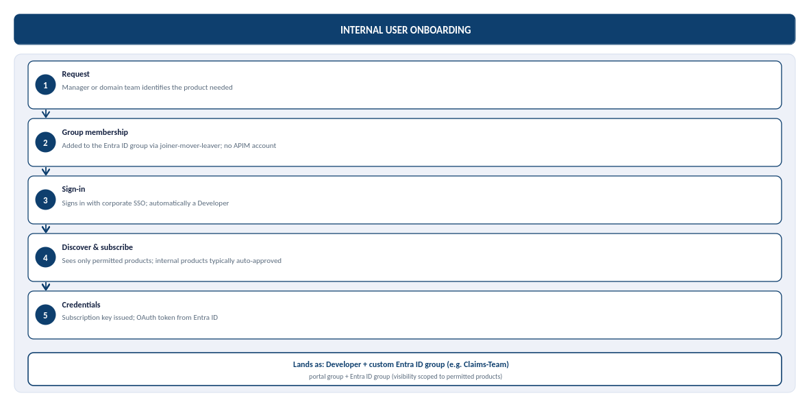
Figure 19b: Internal user onboarding, from request to credentials, and where the user lands in the portal groups
External user onboarding (partner, B2B)
The Organization's external identity default is Microsoft Entra External ID (B2B) for partner organisations, not Azure AD B2C: B2C is no longer available for new deployments, and Microsoft's current recommendation for consumer-facing sign-up is Microsoft Entra External ID. B2B is the correct model here because every external consumer is a known partner organisation, not an anonymous member of the public.
- Sponsorship: a named internal owner sponsors the partner and confirms which product they may access.
- Guest invitation: the partner user is invited as a Microsoft Entra ID B2B guest, authenticating with their own organisation's credentials rather than an organization-issued account.
- Group membership: once the invitation is redeemed, the guest identity is added to a per-partner Entra ID group, scoping visibility to that partner's product only.
- Sign-in and subscribe: the partner signs into the developer portal through B2B guest SSO and requests a subscription; external subscriptions are gated by approval, not automatic.
- Credentials: on approval, a subscription key is issued and, for OAuth-protected APIs, the partner's registered application obtains a token from Entra ID.
Partner sponsorship and credential-rotation ownership are not yet named, alongside the related gaps below.
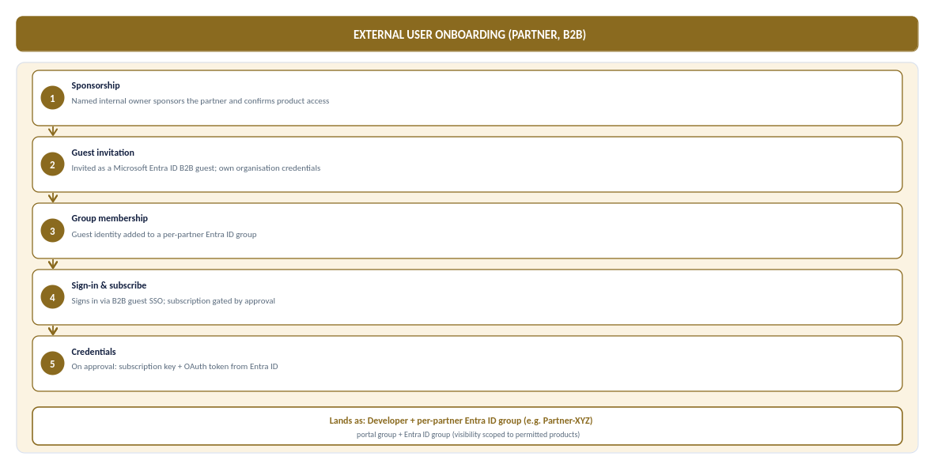
Figure 19c: External (partner, B2B) user onboarding, from sponsorship to credentials, and where the partner lands in the portal groups
In steady-state production the same consumer calls the API through APIM, where JWT validation and per-subscription rate limits and quotas are enforced on every call, and manages their own subscriptions and key rotation from the portal profile area without an organization ticket. The full journey, from access granted to steady-state use, is shown below.
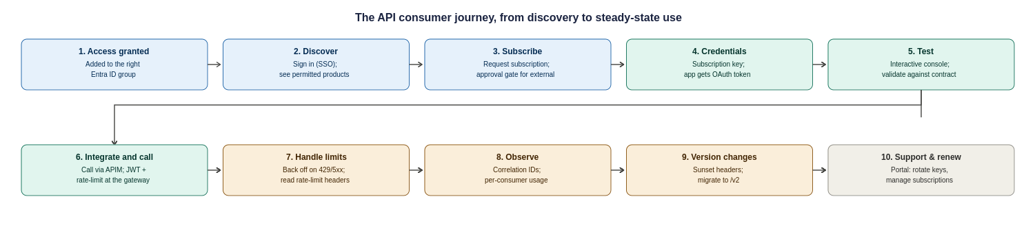
Figure 20: The API consumer journey, ten steps from access granted to steady-state use, support and versioning
Two responsibilities sit with the Organization to make this journey real, and are recorded as operational tasks in the assumptions register: a named owner for approving external subscription requests within an agreed SLA, and a defined support and escalation path (who a partner contacts when a call fails, and how correlation IDs are used to resolve it).

API Policies and Governance
This section complements existing Chaucer Engineering Standards and Cloud Adoption Framework (CAF) guidance and highlights the controls most relevant to APIM. Where any conflict exists, approved enterprise standards take precedence.
Further guidance is available in the Chaucer Engineering Standards and API Governance documentation on Confluence : APIM-Engineering-Standards

API Lifecycle and Versioning Strategy
Every API follows a standard lifecycle from design through retirement, ensuring consistent governance, security and operational management. The lifecycle aligns with Chaucer's engineering standards and API governance practices, with operational insights and monitoring data feeding future enhancements and design decisions.
Further guidance on API delivery, governance and lifecycle management is available in the Chaucer Engineering Standards and API Governance documentation on Confluence: API Life cycle
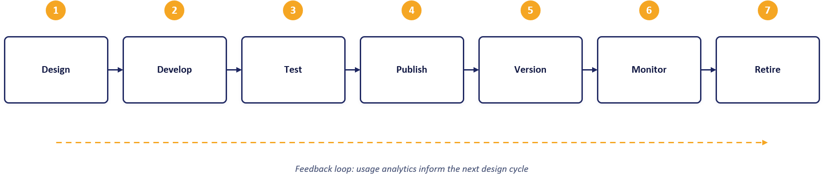

Observability and Operations
Azure Monitor provides a unified observability platform across APIM, policies and backend services. Application Insights delivers end-to-end tracing, Log Analytics stores diagnostic telemetry, and dashboards provide operational, security and management reporting..
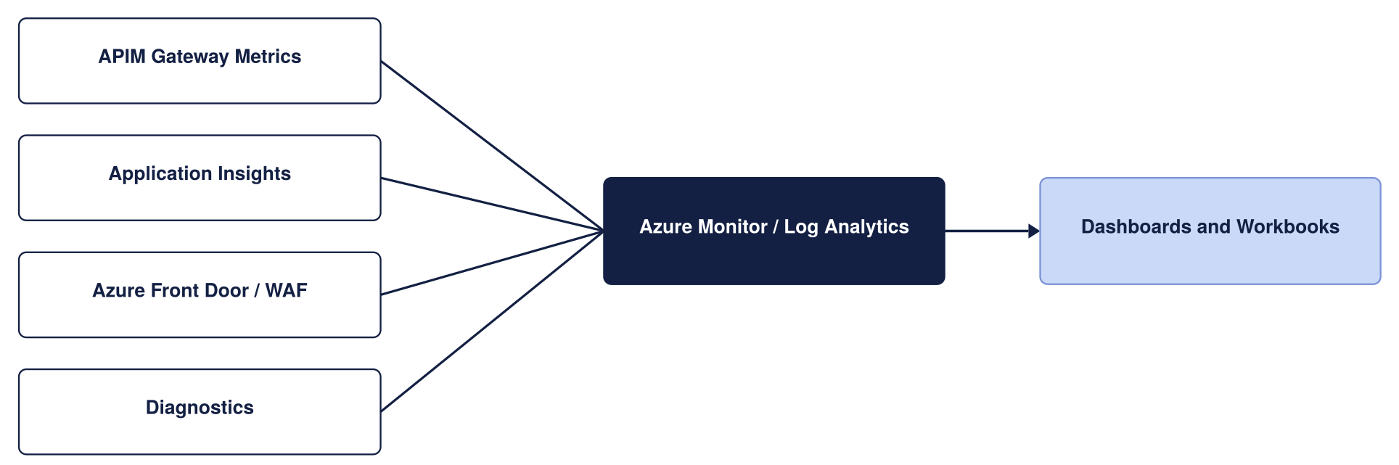
Monitoring architecture
Telemetry and diagnostics are captured through APIM diagnostic settings and correlated using a common correlation identifier. Operational, performance and security telemetry is routed to the appropriate monitoring platform based on its purpose and retention requirements.
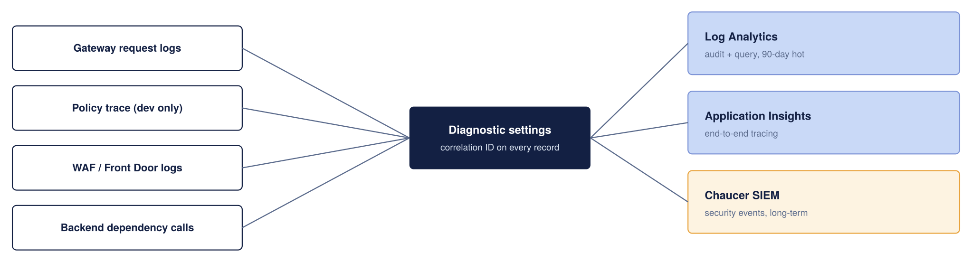
Telemetry Collection and Retention
Telemetry Retention
The retention values below are indicative and should be aligned with the Organisation's logging, security and compliance retention standards..
Telemetry | Sink | Retention (proposed)
Gateway request and response metadata | Log Analytics | 90 days hot, then archived per the Organization’s log policy
End-to-end distributed traces | Application Insights | Sampled in production to control cost
Policy trace (verbose) | Application Insights | Enabled in Dev only; off in production by default
WAF and Front Door logs | Log Analytics | 90 days, forwarded to the security dashboard if applicable
Security-relevant events | Organization SIEM | Retained in accordance with SIEM policy

Correlation and Tracing
Correlation IDs are propagated from APIM to backend services to support end-to-end request tracing. Propagation should be validated during implementation to ensure trace continuity. Verbose policy tracing is restricted to non-production environments due to cost and potential exposure of sensitive information.
Dashboards and Alerting
Dashboards are provided for operational, integration, security and management audiences. Alert thresholds below are proposed defaults and should be refined based on production usage patterns..
Metric | Alert Threshold (Proposed)
Failed requests (5xx) | Greater than 1% of total requests
Gateway response time | p95 above 500ms
Unauthorized requests (401) | Greater than 10 per minute
Certificate expiry | Less than 30 days to expiry

Environment and Release Strategy
Environment | Service tier | Target SLA | Purpose
Dev | Developer | None (No SLA)) | Functional API policy development, mock backend testing, and automated pipeline builds at minimum cost. Non-production evaluation tier.
SIT | Developer | None (No SLA) | Functional API policy development, mock backend testing, and automated pipeline builds at minimum cost. Non-production evaluation tier.
UAT | Premium V2 | 99.95% | Pre-production business sign-off and user acceptance. Guarantees complete architectural parity with Production (VNet Injection, Private Endpoints, isolated networking) on a single scale unit.
Production | Premium V2 | 99.95% | Live customer traffic, high availability. Deployed across 2 Availability Zones (Silver Tier) with dynamic autoscaling based on gateway CPU/Memory load

The platform environment strategy uses four distinct environments: Dev, SIT, UAT, and Production.
- Dev and SIT: Provisioned on the cost-effective Developer tier to support functional API policy development, mock testing, and automated integration pipeline builds at minimal cost.
- UAT: Provisioned on Premium v2 (1 scale unit) to ensure complete pre-production architectural and network parity (VNet Injection, Private Endpoints) with Production, providing a supported, SLA-backed platform for business sign-off and user acceptance testing.
- Production: Provisioned on Premium v2 with Zone Redundancy enabled (Silver Tier across 2 Availability Zones) for live customer traffic, maximum platform availability, and dynamic autoscaling capabilities.

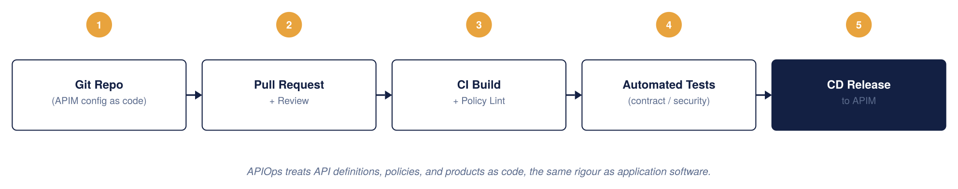
APIM CI/CD model, APIOps
APIOps Tooling and Deployment Pipeline
This design adopts an APIOps operating model, aligned to Chaucer's existing Azure delivery approach and platform engineering standards.
- Infrastructure as code: Terraform is used to provision and manage APIM, networking, Front Door, Key Vault and supporting Azure resources. Environment-specific behaviour is controlled through approved configuration and parameterisation rather than separate infrastructure definitions..
- Configuration as Code: APIM APIs, products, policies, named values and related configuration are maintained in source control and deployed through automated pipelines. Configuration is managed as code rather than through manual changes in the Azure portal
- Source Control and CI/CD: Azure Repos provides source control, with Azure DevOps Pipelines used for build, validation and deployment. All changes are subject to pull-request review and approval prior to deployment..
- Environment promotion: Changes are deployed to Development through the CI/CD pipeline and promoted through SIT, UAT and Production using the same approved artefacts. Production deployments are governed through approval gates and change management processes

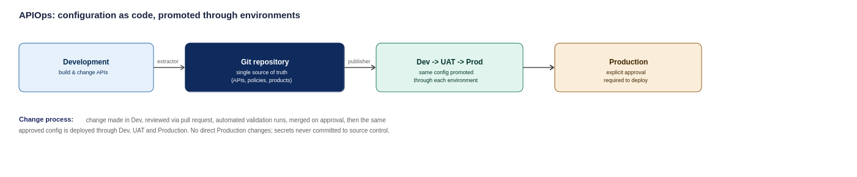
APIOps deployment pipeline, from development through to production

Configuration Management & Security Principles

Environment-Specific Settings
Environment-specific configuration (e.g., backend endpoints, rate-limit thresholds, and timeout values) are managed via environment-specific configuration files. API schemas, OpenAPI specs, and XML policies remain identical across all deployment stages.

Security Baseline
- Secrets Governance: Credentials, certificates and keys are stored in Azure Key Vault and referenced securely during deployment and runtime.; zero plain-text secrets are committed to source control.
- Least Privilege: APIOps deployment identities use scoped Workload Identity / Service Principal credentials with minimal required Azure RBAC roles.
- Pipeline Enforcement: Production changes are deployed exclusively through approved CI/CD pipelines. Direct portal modifications are not permitted except through approved emergency procedures.
- Emergency Override: Direct production portal access is restricted to time-bound Emergency Administrative Access (via Azure PIM) and is reserved strictly for pipeline outages.
Repository Structure
The APIOps repository maintains a single, standardized layout containing:
- APIs/ OpenAPI definitions and endpoint configurations
- Policies/ Inbound, outbound, backend, and error XML policies
- Products/ —API product groupings and subscription key settings
- NamedValues/ APIM-level global properties and Key Vault references
- Backends/ Gateway backend target pool definitions
- Environments/ —Environment-specific config mapping files (Dev, SIT, UAT, Production)
- Pipelines/ CI/CD deployment workflow and validation scripts
Configuration is promoted through Dev $→$ SIT $→$ UAT $→$ Production via automated promotion gates, ensuring consistency across environments.

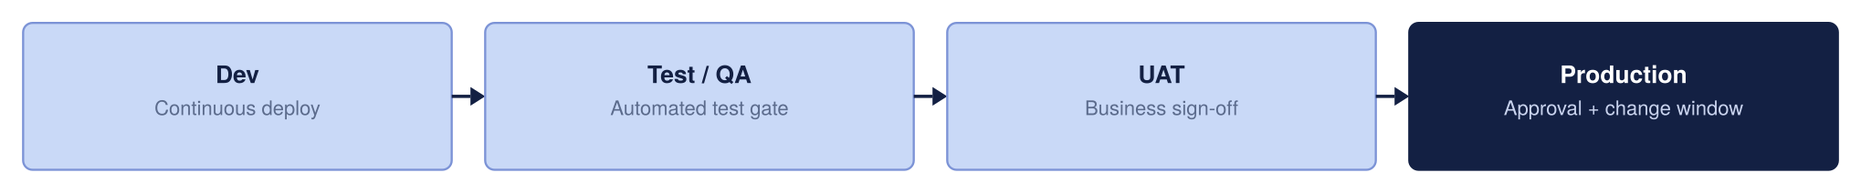
Environment promotion strategy

High Availability and Resilience Strategy
High Availability ensures the platform survives a datacentre failure within a region without disrupting users. By deploying APIM across independent Azure Availability Zones, traffic is automatically routed only to healthy zones.
Active-active multi-region deployment roughly doubles overall platform running costs, which is not justified for every API. To balance high availability with fiscal responsibility, resilience is tiered based on business criticality rather than paying a multi-region cost premium across the entire estate
Bronze (Single Region – Single Unit): Deployed in a single Azure region without secondary region or cross-zone failover. Service recovery relies on standard platform restoration processes, prioritizing cost efficiency for non-critical workloads where extended recovery times are acceptable.
Silver (Single Region – More Than 1 Unit): Preferred Baseline: Deployed within a single Azure region using multiple units distributed across Availability Zones (e.g., Zone 1 and Zone 2). This provides high intra-region capacity and local fault tolerance against underlying infrastructure or maintenance failures without incurring the cost and complexity of a secondary standby region.
Gold (Multiple Region – Multiple Units): Deployed across multiple Azure regions with multiple units provisioned in each region, offering geographic distribution, active load balancing, and cross-region failover for business-critical production services.

Resilience Tier | Deployment Topology | Architectural Scope | Operational Effect | Key Benefits | Architectural Trade-offs
Bronze | Single Region,  Single Unit | APIOps / IaC Git Config Recovery  Azure Front Door Anycast & WAF Edge | Environment can be completely rebuilt from code (near-zero config RPO).  DDoS and web attacks absorbed at the edge. | Minimizes platform infrastructure, licensing, and operational management costs. | No cross-zone or cross-region failover. Relies entirely on standard platform recovery procedures during outages.
Silver (Chosen Baseline & Production Standard) | Single Region,  Multiple Units (2 AZs) | Zone-Redundant APIM Gateway | Survives single physical datacentre loss within the region.  Traffic automatically routes around failed zones without manual intervention. | High intra-region availability and fault tolerance against local zonal/maintenance events. | Accepts an RTO window during a total regional outage in exchange for avoiding secondary-region running costs.
Gold | Multi-Region,  Multiple Units | Multi-Region Active-Active APIM (UK South / UK West)  Front Door Global Health Probes | Full regional disaster recovery.  Total UK South outage automatically routes traffic to UK West or another approved region with no client DNS changes. | Highest possible resilience tier with automated geographic failover and continuous multi-region availability. | High operational complexity; roughly doubles platform infrastructure and licensing costs.

Bronze and Silver run the primary region only, to keep cost minimal. Gold runs actively across both regions.
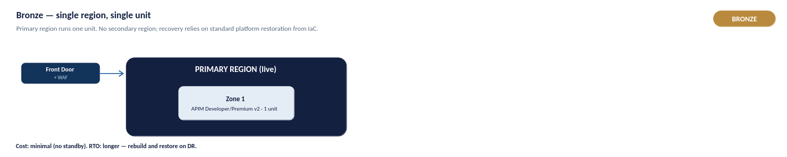
Figure 32a: Bronze — single region, single unit
Bronze is a single region running one unit, with no secondary region or cross-zone failover. Recovery relies on standard platform restoration, and the environment can be rebuilt from IaC (near-zero configuration RPO). It minimises infrastructure and licensing cost, and suits non-critical workloads where a longer recovery time is acceptable.
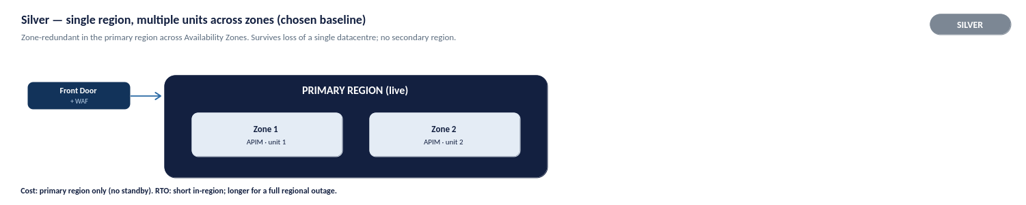
Figure 32b: Silver — single region, multiple units across zones (chosen baseline)
Silver is the chosen production baseline: a single region with multiple units distributed across Availability Zones. It survives the loss of a single datacentre within the region, with traffic automatically routed around a failed zone, and gives high intra-region availability without the cost of a standby region. It accepts an RTO window during a total regional outage in exchange for avoiding secondary-region running costs.
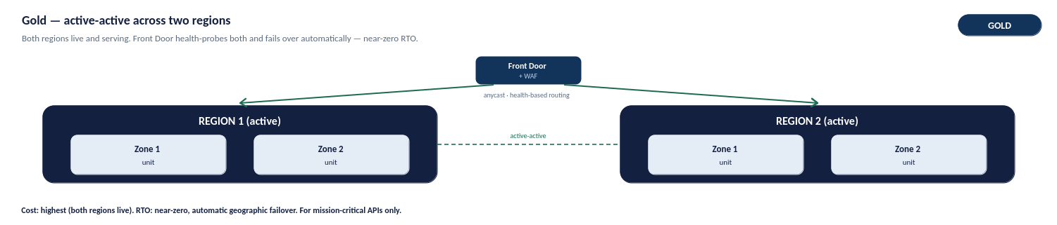
Figure 32c: Gold — active-active across two regions
Gold is reserved for mission-critical services: multiple units deployed active-active across two regions (UK South and UK West), with Front Door health-probing both and failing over automatically. A total regional outage reroutes traffic with no client DNS change, giving the highest resilience tier. The trade-off is higher operational complexity and roughly double the platform running cost, so it is applied only where the business case justifies it.

Capacity, Cost and Service Tiers
The costs below are indicative UK South list prices and should be validated against current Microsoft pricing, enterprise agreements and expected traffic volumes..
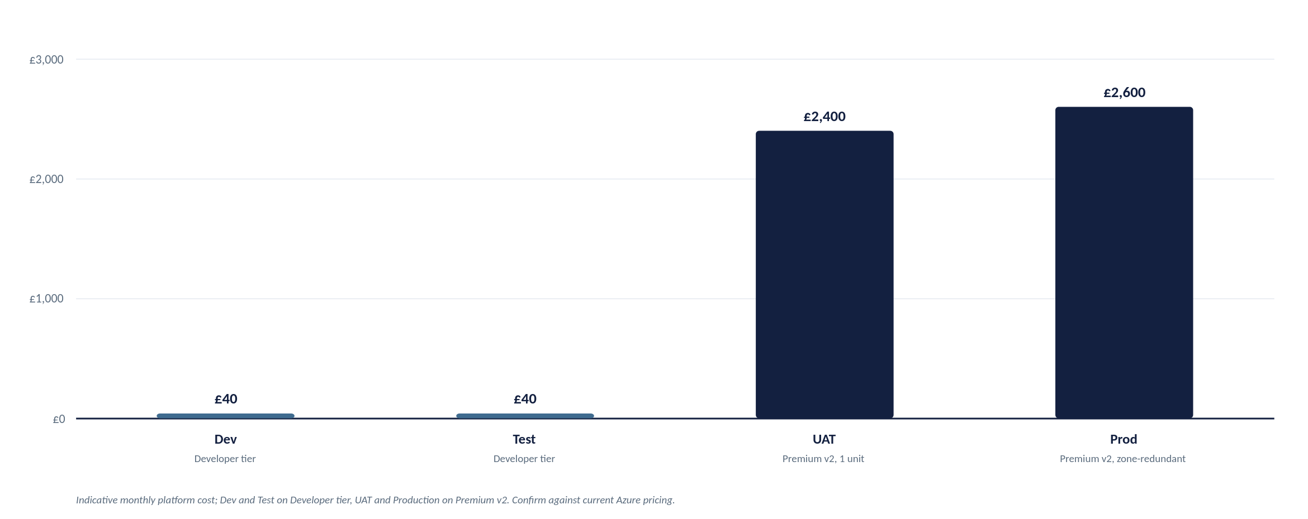
Indicative monthly platform cost by environment
Figures are indicative and must be confirmed against current Azure pricing: azure.microsoft.com/pricing/details/api-management
Cost per Component (Production)

Component | Indicative monthly cost | Notes
APIM Premium V2 | ~ £2,100 to £2,300 (per unit) | Modern v2 architecture eliminates legacy Cloud Services (Classic) dependencies. Zone redundancy (2 AZs) is configured within the region.
Azure Front Door Premium + WAF | ~ £260 base, plus usage | In Premium v2, multi-region failover relies on Front Door orchestrating independent regional v2 instances. Includes WAF base rules
Azure Key Vault | Low cost | Centralized secret and TLS certificate storage; operational cost is negligible.
Azure Monitor and Application Insights | Usage-Based | Cost driven by telemetry volume and retention requirements.
Azure DDoS Protection (Dedicated Plan) | ~ £2,300 per month per tenant | Flat tenant-wide fee covering up to 100 public IPs (optional if relying purely on Front Door edge protection).

Recommendation: Dedicated Azure DDoS Protection is not included in the baseline design. Front Door Premium and WAF provide the primary perimeter protection model for the proposed architecture.
Cost Optimization Strategies
- Tier Sizing Across Environments:
  - Dev / Test: Deploy a single Developer tier instance to provide functional parity with Premium v2 capabilities, including policy development, API lifecycle testing, products, subscriptions and networking validation, while avoiding Premium-tier cost in non-production environments.
  - UAT / Pre-Prod: Deploy a single Premium v2 unit aligned to the Silver deployment model. This provides production-equivalent networking, security and SLA characteristics without the cost of a multi-region deployment.
- Demand-Driven Capacity Scaling: Start production with a single Premium v2 unit and scale based on observed workload characteristics, gateway utilisation and service-level requirements. Additional capacity should be added only when supported by operational metrics and demand trends.
- Observability & Log Ingestion Management: Application Insights and Log Analytics are usage-based services. Apply telemetry sampling where appropriate, retain verbose diagnostics only for troubleshooting or high-value APIs, and align retention settings with operational and compliance requirements.

Capacity Planning and Scaling

Platform cost and throughput scale directly with the number of provisioned units. As an initial planning baseline, 1 Premium v2 unit handles roughly 1,000 requests/sec, but this is an estimate. Actual throughput varies based on payload size, policy evaluation complexity, and TLS overhead, requiring validation against real production traffic.
Scaling Principles:
- Auto scale Thresholds: For multi-unit instances, scale out when sustained gateway CPU or memory exceeds ~70%, and scale in below ~35% over a 30-minute average.
- Provisioning Lead Time: Scale operations take 15–30 minutes to complete. Auto scale rules must react to sustained trends rather than short bursts.
- Active-Active Sizing: Each active region must carry sufficient unit headroom to absorb 100% of the peak workload during a single-region failover.

Environment | Service Tier | Starting Capacity | Indicative Throughput | Architectural & Sizing Justification
Dev | Developer | 1 Unit | N/A  (Build / Unit Test) | Supports API development, policy authoring, functional testing and APIOps validation with capabilities aligned to the target production model at minimal cost.
SIT | Developer | 1 Unit | N/A  (Build / Unit Test) | Supports integration testing, environment validation and pre-UAT verification without Premium-tier licensing costs.
UAT | Premium v2 | 1 Unit | ~1,000 req/sec | Production-aligned environment supporting VNet Injection, private connectivity and enterprise networking validation prior to business sign-off.
Production | Premium v2 | 2 Unit | ~1,000 req/sec  per unit | Recommended Silver-tier production baseline. Deployed across Availability Zones for high availability and scaled based on observed demand, operational metrics and service-level objectives.

Operating Model
This section details live platform operations: incident response, release management, capacity planning, and cost governance. It builds directly on the ownership model (Section 10.2), monitoring framework (Section 12), and release pipelines (Section 13)

Operational ownership and support tiers
Ownership follows Chaucer's operating model. The Integration Team owns the APIM platform configuration, including APIs, products, subscriptions, policies and governance controls. The Platform Team owns the underlying infrastructure and networking, while DevSecOps owns deployment pipelines and automation. Network, Identity, Security and Compliance teams continue to own their respective controls and standards across the platform.
The diagram below illustrates the operational support and escalation model, including standard service support paths and direct escalation routes for security-related events.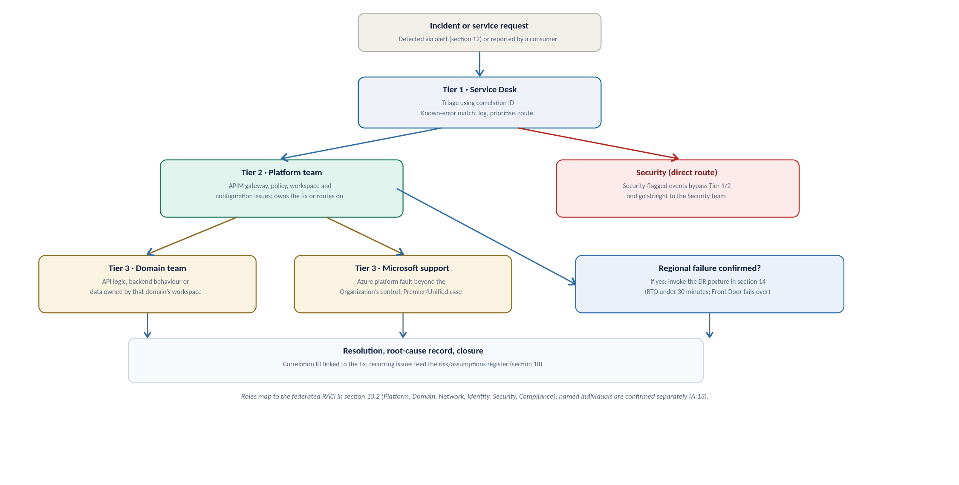
Figure 33a: Operating model at a glance, the support tiers and escalation path from an incident to closure
Support Tier | Scope of Ownership & Operational Responsibility | Escalation Path & Target
Tier 1  (Service Desk) | First Response & Triage. Ingests alerts, performs initial triage using the API Correlation ID (Section 12), and performs known-error matching. | Escalates to Tier 2 (Platform Team) for unresolved issues or platform-level errors.
Tier 2  (Platform Team) | APIM Platform Infrastructure. Owns the core gateway, global policies, shared infrastructure, workspace provisioning, and network routing configurations. | Escalates to Tier 3 (Domain Team) for application logic issues, or Microsoft Support for Azure platform outages.
Tier 3  (Domain Team) | API Logic & Backend Services. Owns backend microservices, domain-specific policies, API schemas, and data within their dedicated workspace. | Domain-owned internal resolution.
Tier 3  (Microsoft Support) | Azure Platform & Infrastructure. Handles platform-level outages, underlying hypervisor faults, or Microsoft-managed control plane failures. | Logged as a Premier / Unified Support ticket directly with Microsoft.
Security  (Direct Fast-Path) | Threat & Compliance Management. Direct escalation route for security-flagged events (e.g., active WAF attacks, credential leaks, or unauthorized access attempts), bypassing Tiers 1 and 2. | Managed directly by the InfoSec / SOC Team.

Named individuals for each tier are not yet assigned, this is the same open item as the RACI owners in A.13, and should be closed before go-live (see section 17.1).

Incident management
Severity is set by impact and matched to the alert thresholds already defined in section 12. These are proposed definitions to align with the Organization's ITSM standard, and final response and resolution targets are agreed with the Operations team, consistent with A.09.
Severity | Example trigger | Target response | Target resolution or mitigation
Sev 1, Critical | Regional outage, or 5xx errors above 1% platform-wide | 15 minutes | Automatic regional failover (section 14, RTO under 30 minutes); manual escalation if it does not clear
Sev 2, High | A single product degraded, or p95 latency sustained above 500ms | 1 hour | Same business day, through a standard or emergency change
Sev 3, Low | An isolated consumer issue, or a certificate nearing expiry | Next business day | Resolved through the standard change and release cadence

Every incident is linked to its correlation ID so the root cause can be traced end to end, and a recurring issue is fed into the risk register in section 18 rather than fixed quietly and forgotten.

Change and release management
Change control is embedded directly within the APIOps automated pipeline (Section 13) rather than operating as a separate manual CAB process. Every modification whether to an API policy, OpenAI spec, or gateway configuration passes through pull-request (PR) peer reviews, automated static security analysis, and environment promotion gates before reaching Production.
- Standard change: Any routine API definition, policy update, or workspace configuration change. Follows the standard multi-stage pipeline, requiring peer review, automated validation, and gated promotion through Dev, Test, UAT, and Production.
- Emergency change: A hotfix required to resolve an active Severity 1 or Severity 2 incident outside the normal release cadence. Emergency changes must still execute through the APIOps pipeline and Git history, utilizing an expedited PR approval path (e.g., single platform lead sign-off). A mandatory Post-Implementation Review (PIR) is logged against the incident ticket upon deployment.
- Emergency Administrative Access: The emergency platform-team access path (defined in Section 10.2), invoked only when the APIOps pipeline control plane is entirely unavailable (e.g., CI/CD provider outage). Access requires time-bound Azure Privileged Identity Management (PIM) elevation, triggers immediate security alerts, and undergoes mandatory post-incident auditing. It is strictly prohibited for routine operational changes.

Capacity, cost and service reporting
Capacity and cost are reviewed on a recurring cycle, not just at design time: actual traffic is compared against the planning assumptions in section 15 and A.10/A.12, and the tier, unit count, and multi-region posture are revisited as real volumes replace estimates.
Service reporting reuses the dashboards already defined in section 12 (Figure 25, Figure 26): an operational view for the Platform and Domain teams, and an executive view rolling up availability against the SLA. A regular service review, cadence to be agreed with the Organization's Operations team, is the forum where this reporting, open risks, and upcoming changes are reviewed together.

Service Transition Considerations
The following capabilities must be in place prior to production onboarding:
- Operational ownership assigned.
- Monitoring and alerting configured.
- APIOps pipeline operational.
- Backup and recovery procedures documented.
- Security logging integrated with organisational monitoring platforms.
- Runbooks and support documentation completed.
Detailed service acceptance, hypercare and operational handover activities are managed through the Organisation's existing service transition and operational governance processes.
This section sets out what must be true before the platform moves from build into business-as-usual operation, and how that transition is managed. It is the operational counterpart to the Technical Design Authority approval in section 1: TDA approval signs off the design. The criteria below sign off that the live service is ready to run.

Handover readiness checklist
Handover is not a single event but a checklist: the items below should be true, or have a named owner and a date to become true, before the service is accepted into live support.
Governance & Operational Area | Service Readiness Criterion | Design & Reference
Platform Ownership | Accountable primary and secondary owners assigned for every RACI role defined in Section 10.2. | Section 10.2 (Closes Risk A.13)
Support Readiness | Support Tiers 1 through 3 staffed, briefed on operational escalation paths, and on-call rosters established. | Section 16.1
Observability & Alerting | Azure Monitor dashboards live, Log Analytics ingestion verified, and alert routing/thresholds tested end-to-end with Operations. | Section 12 (Closes Risk A.09)
Platform Resilience | Front Door health probes and multi-region failover (or single-region AZ availability) tested and documented prior to go-live. | Section 14
Policy Exceptions | Operational process, ownership, and SLA established for evaluating and approving non-OAuth or legacy policy exception requests. | Closes Risk A.16
Operational Documentation | Operational runbooks, final HLD architecture, and the assumptions/risk register delivered to support teams. | Section 17.3
Identity & Access Control | CI/CD APIOps pipeline permissions, Git repositories, Key Vault access, and Emergency Administrative Access (PIM) transferred to operational owners. | Section 10.2 & Section 13
Vendor & Commercial | Active Microsoft Enterprise Support agreement (Premier/Unified) confirmed, with support ticket logging paths validated. | Section 16.1

Early-life support
Industry practice for a core platform of this nature requires a defined Hypercare period immediately following Production go-live, typically spanning two to four weeks.
During Hypercare:
- Joint Operational Standing: The engineering and build team remain actively engaged alongside Tiers 1 and 2 support to ensure rapid incident triage and direct knowledge transfer.
- Aggressive Escalation: Escalation thresholds are intentionally lowered compared to steady-state operations to resolve early adoption friction rapidly.
- Daily Incident Review: A daily operational cadence reviews open tickets, pipeline health, telemetry logs, and emerging usage patterns.
Transition Gate: Hypercare concludes and the standard operational support tiers (Section 16.1) take over full steady-state ownership only when formal Hypercare Exit Criteria are satisfied, including:
- Zero Sev-1 or Sev-2 incidents for a minimum of 5 consecutive business days.
- Zero unresolved high-priority bugs in the APIOps deployment pipeline.
- Formal sign-off on operational runbooks and all completed items in the Handover Readiness Checklist

Documentation and knowledge transfer
To ensure seamless operational continuity, the delivery team will formally transfer the following key assets to operational owners prior to Hypercare exit, rather than retaining them within project delivery:
- APIM High-Level Design (HLD): Maintained as a living architectural baseline and updated via version control as the platform evolves, consistent with the broader Systems Integration Framework governance model.
- Operational RACI & Contact Directory: Sections 10.2 and 16.1 updated with named primary/secondary contacts, on-call schedules, and escalation paths substituted for generic roles.
- Operational & Resilience Runbooks: Operational runbooks specifically including the Emergency Administrative Access procedure (Section 10.2) and the Front Door / Regional resilience playbook (Section 14) stored as Markdown directly alongside infrastructure-as-code (IaC) repositories.
- Risk, Assumption, Issue & Dependency (RAID) Register: Section 18 carried forward into steady-state operations and reviewed on a scheduled cadence during periodic platform service reviews (Section 16.4).
- APIOps & Security Access Control: Full administrative ownership of the APIOps CI/CD pipelines, Git control repositories, Key Vault access policies, and Azure Privileged Identity Management (PIM) roles transferred to designated operational platform owners.

Service acceptance sign-off
Formal acceptance into live production operation is a distinct governance gate, separate from the initial Technical Design Authority (TDA) approval in Section 1:
- TDA Approval (Section 1): Signs off on the technical architecture, security baseline, and sizing strategy prior to build execution.
- Service Acceptance Sign-Off: Formally validates that every criterion in the Handover Readiness Checklist (Section 17.1) is fully met, verified during Hypercare, and ready for steady-state operation

Risks, Assumptions and Decisions

High Level Impact Assessment
Introducing APIM adds a centrally governed API platform in front of the existing integration estate. Existing integration services continue to operate unchanged, with APIM providing a standardised entry point for API exposure, governance and policy enforcement. Primary dependencies include networking, identity and APIOps capabilities

Assumptions
This register identifies assumptions and outstanding decisions requiring validation and approval prior to implementation.
Ref | Assumption or open item | Impact if Incorrect | Owner to confirm
A.01 | Backend services are reachable through approved private connectivity. | Backend connectivity design may require rework. | Network team
A.02 | The Organization’s landing zone follows a standard hub-spoke with private DNS zones available | Affects DNS, egress, and how APIM reaches each backend | Platform Team
A.03 | Entra ID is the Organization’s identity provider and can extend to API consumers | Authentication and authorization model may require redesign. | Identity Team
A.04 | Proposed RTO/RPO, retention periods, and alert thresholds are acceptable | Operational targets and cost may change | Operations Team
A.05 | Initial workloads can be supported by a single Premium v2 unit. | Additional capacity may be required earlier than planned. | Integration Team
A.06 | Expected and peak API request rate (RPS) are not yet confirmed | Capacity planning remains indicative until validated. | Platform team
A.07 | Operational ownership and RACI assignments are not yet confirmed. | Governance and support responsibilities remain incomplete. | Platform Team and Service Owners
A.08 | Log retention and correlation-data retention requirements are not yet confirmed. | Compliance and audit requirements may not be fully satisfied. | Security Teams
A.09 | Network sizing and IP allocation requirements are not yet validated. | Subnet sizing and platform scalability assumptions may be affected. | Network Team
A.10 | Exception ownership and approval processes for non-standard authentication methods are not yet defined | Authentication exceptions may lack governance and review ownership. | Security Team and API Platform Team

Risks

Issues
No live issues are recorded at draft stage. Issues raised during TDA review or build will be logged here.

Dependencies
Ref | Dependency | Owner
D.01 | Entra ID app registrations provisioned before build | Identity Team
D.02 | Azure Key Vault provisioned and access policies configured in the target subscription. | Platform team
D.03 | Landing-zone network connectivity, subnets and Palo Alto routing paths available in the target environment. | Network Team
D.04 | RTO, RPO, retention requirements and alert thresholds agreed and approved. | Operations team

Appendices

Microsoft Reference Architectures
Diagrams in this document are the Organization-adapted renderings of the pattern each article describes, not reproductions of Microsoft's own diagrams. Refer to the linked articles for Microsoft's original diagrams and downloadable Visio files.
- Basic enterprise integration on Azure: learn.microsoft.com/azure/architecture/reference-architectures/enterprise-integration/basic-enterprise-integration
- Protect APIs with Front Door and API Management: learn.microsoft.com/azure/architecture/web-apps/api-management/architectures/protect-apis
- Azure API Management landing zone accelerator: learn.microsoft.com/azure/cloud-adoption-framework/scenarios/app-platform/api-management/landing-zone-accelerator

Alignment with the Azure Well-Architected Framework
This design has been benchmarked against Microsoft's Well-Architected Framework (WAF) guidance for API Management, which sets out best practice across five pillars. The table below summarises each pillar, the key practices Microsoft recommends, and where this HLD addresses them. The alignment is high because the design was built to these patterns; the few items marked as configuration are settings to apply at build time rather than design gaps.
WAF Pillar | Key Microsoft Recommendations | How This APIM Design Addresses It
Reliability | Zone redundancy, autoscaling, multi-region failover, policy validation, reliability metrics, and GitOps rebuild capabilities. | APIM Premium v2 deployed as active-active independent regional instances behind Azure Front Door Premium (Silver Resiliency Tier). Native Availability Zone redundancy; APIOps config-as-code enables rapid automated environment recreation.
Security | ARM-only control plane, strict TLS, Key Vault integration, network-isolated backends, OAuth 2.0, Managed Identity, edge WAF, and production trace restrictions. | Microsoft Entra ID OAuth 2.0 with JWT validation, TLS 1.2+ minimum, Key Vault-backed Named Values, Azure Front Door WAF edge inspection; Managed Identity for backend access, Private Endpoints; verbose tracing restricted to Dev/Test.
Cost Optimization | Cost-effective tiering across non-prod, auto-scale based on load, edge malicious traffic filtering, built-in caching, and policy efficiency. | 4-Environment Topology: Developer tier for Dev and Test, Premium v2 for UAT and Production (ensuring strict VNet/Private Endpoint parity). Edge DDoS and WAF filtering via Azure Front Door blocks malicious calls prior to gateway ingress.
Operational Excellence | Diagnostic resource logging, APIOps / GitOps workflows, Azure Policy governance, automated load testing, standard hostnames, and Backend construct abstraction. | Azure Monitor / Log Analytics / App Insights integration with trace parent correlation IDs, APIOps CI/CD pipelines across Dev/Test/UAT/Prod, standardized API onboarding, backend health probes managed via APIM Backends.
Performance Efficiency | Dynamic scaling, efficient policy execution, performance metric collection, adaptive App Insights sampling, and upstream limits evaluation. | Autoscaling driven by Gateway Capacity and CPU/Memory metrics, lean, modular policy library, p95 latency and capacity alerts, production Application Insights adaptive sampling to minimize overhead.

Based on Microsoft’s Azure Well-Architected Framework guidance for API Management: learn.microsoft.com/azure/well-architected/service-guides/api-management
Source: Microsoft Azure Well-Architected Framework, Architecture best practices for Azure API Management. The full checklist and per-recommendation detail are maintained by Microsoft at learn.microsoft.com and are summarised, not reproduced, here.

Glossary and Definitions
The terms below are used throughout this document.
Term | Meaning
APIM | Azure API Management, the managed API gateway service
WAF | Web Application Firewall
Entra ID | Microsoft Entra ID, the identity provider (formerly Azure AD)
UDR | User-Defined Route, a custom route-table entry
NVA | Network Virtual Appliance, here the Palo Alto firewall
APIOps | Managing APIM configuration as code through a CI/CD pipeline
RTO / RPO | Recovery Time / Point Objective
mTLS | Mutual TLS
FNOL | First Notification of Loss, the initial report of an insurance claim
SIF | Systems Integration Framework, the client’s integration reference document
RACI | Responsible, Accountable, Consulted, Informed, a responsibility model
BOLA | Broken Object-Level Authorization, an OWASP API risk
SoD | Segregation of Duties
HLSA | High-Level Solution Architecture
DNAT / SNAT | Destination / Source Network Address Translation
IPAM | IP Address Management
SIEM | Security Information and Event Management
DPIA | Data Protection Impact Assessment
FCA | Financial Conduct Authority, a UK regulator
PRA | Prudential Regulation Authority, a UK regulator
UK GDPR | UK General Data Protection Regulation
JWT | JSON Web Token
DDoS | Distributed Denial of Service
SLA | Service-Level Agreement
VNet | Azure Virtual Network
Private Link | Private connectivity to an Azure service over the Microsoft backbone

Sample Policy Fragments, Naming and OpenAPI Skeleton
Illustrative artefacts to make the standards concrete for build teams. These are examples to adapt, not final Organization policy.
JWT validation (inbound) with Entra ID:
<validate-jwt header-name="Authorization" failed-validation-httpcode="401"
failed-validation-error-message="Unauthorized">
<openid-config url="https://login.microsoftonline.com/{tenant}/v2.0/.well-known/openid-configuration" />
<required-claims>
<claim name="aud"><value>api://organization-apim</value></claim>
</required-claims>
</validate-jwt>
Rate limiting and quota, per subscription:
<rate-limit-by-key calls="100" renewal-period="60"
counter-key="@(context.Subscription.Id)" />
<quota-by-key calls="100000" renewal-period="86400"
counter-key="@(context.Subscription.Id)" />
Sunset header during a deprecation window:
<set-header name="Sunset" exists-action="override">
<value>Sat, 30 Nov 2026 23:59:59 GMT</value>
</set-header>
<set-header name="Deprecation" exists-action="override"><value>true</value></set-header>
Backend authentication using a managed identity (no secret in policy):
<authentication-managed-identity resource="api://organization-backend" />
Resource and API naming examples:
Resource group : rg-apim-prod-uksouth
APIM instance : apim-organization-prod-uksouth
API path : /api/claims/v2/claims
Named value : nv-claims-backend-baseurl
Product : prod-external-broker
Entra group : grp-apim-external-broker
OpenAPI skeleton (the contract every API starts from):
openapi: 3.0.3
info:
title: Claims API
version: "2.0.0"
servers:
- url: https://api.organization.example/api/claims/v2
paths:
/claims/{id}:
get:
summary: Retrieve a claim
security:
- oauth2: [claims.read]
parameters:
- name: id
in: path
required: true
schema: { type: string }
responses:
"200": { description: OK }
"401": { description: Unauthorized }
"429": { description: Too Many Requests }

APIM End-to-end build and API onboarding flow
This appendix synthesizes the complete platform journey into a single end-to-end swim lane diagram. Positioned as the final summary, it maps the lifecycle from business need through go-live to ongoing API onboarding.
How to Read the Diagram:
- Phases (Columns): Read left-to-right across seven sequential execution phases.
- Ownership (Rows): Read top-to-bottom to see which team owns each activity.
- Handovers & Gates: Arrows indicate team handovers; red markers highlight mandatory Technical Design Authority (TDA) approval gates.
- Document References: Each activity box cites its corresponding HLD section for detailed reference.
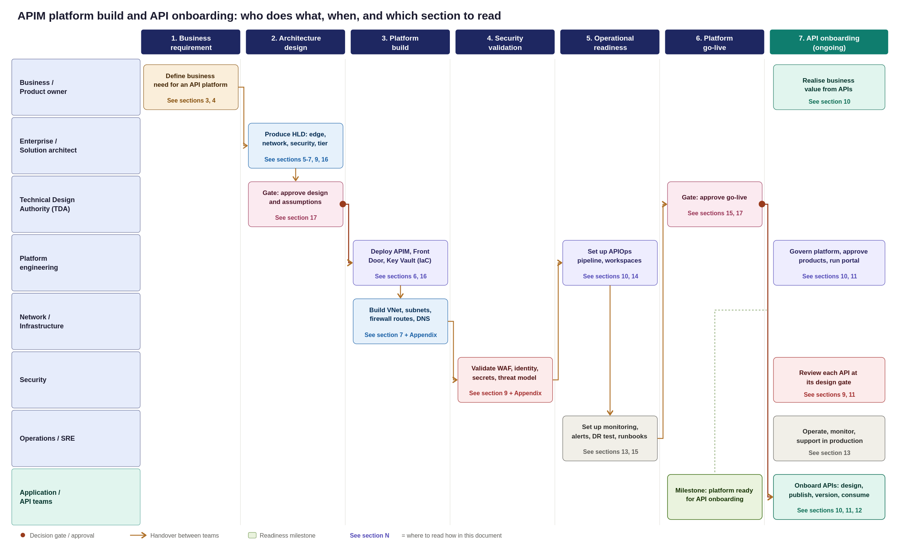
Figure 34: APIM platform builds and API onboarding swim lane, from business requirement to production consumption
Platform Implementation Roadmap & Team Execution
This appendix synthesizes the preceding design sections into a single, end-to-end swim lane diagram, mapping the platform journey from initial business demand to a live operational state.
Key Planning Takeaways
Standing up the APIM platform is a sequenced, multi-team program with a clear critical path:
- Architecture & Governance: TDA sign-off and baseline design approval.
- Infrastructure Build: Parallel execution of platform and network provisioning.
- Validation & Readiness: Security assessment, APIOps integration, and operational handover.
- Go-Live Gate: Final operational acceptance sign-off.
- Continuous Onboarding: Application teams begin onboarding APIs only after the platform go-live gate is passed.
How to Read the Swimlane Diagram
- Phases (Columns): Read left-to-right across the seven sequential execution phases.
- Ownership (Rows): Read top-to-bottom to see which team owns each specific activity.
- Handovers & Gates: Arrows indicate team handovers, while red markers highlight mandatory TDA approval gates.
- Section References: Each activity box references its corresponding HLD section for detailed technical specifications.

